**IY5606 Security Testing**

Highlights: (not a pentest learning module)

* Criticise false epistemology (methodologies)
* Walk a sparse tree in depth first manner (finding hosts via reverse DNS lookup)
* Generic time-memory trade-offs to invert one-way function (PW cracking)
* Exploit side-channel leakage   
  (TCP/UDP idle scanning)
* Utilize Turing Completeness of printf()   
  (format string attacks)
* Use that elements in finite rings are not ordered (integer overflow attacks)

**EXAM == emphasise applied knowledge + problem solving (much more exams prior to 2018)**

Information security assessment = process of determining how effectively an entity being assessed (host, system, network, procedure, person = assessment object)

Methods

* Examination
* Interviewing
* Testing
  + Target identification and analysis
  + Target vulnerability validation

Security

* Verification that secure procedures are correctly carried out
* Compliance with … (e.g. PCIDSS)

Security testing == Pentesting

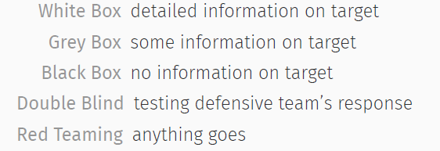

Whitebox = initimate details on network, how it operates, potential weakness, infra, ip, subnets

* Highlights risk related to malicious insider/attackers who has access to significantly exposed info

Grey Box = common, where org provide some info to improve the accuracy of results + increase timeliness of feedback (reduce cost of engagement)

* Info of IDS/IPs in place

It’s not best of both world. But it’s that given this set of information, these are the results of the test that is retrieved.

Blackbox = no info, other than organisation. Uses google. Important to validate targets (authorized/owned by requesting organisation)

Double Blind = test of not only from env, but Also monitoring + incident response of ORG

* Engagement must be well established
* Include post mortem discussion and verification of specific activity was detected + what should have been detected
* Results of these types of engagement = useful determining how well the defensive teams and tuned + potential gaps

Red teaming = physical, social engineering, data extraction+ exfiltration, more time + cost

Pentesting = MORE THAN attacking

WE Look and consider issues

* Mgmt. + methodology
  + Provides consistency + structure to testing
  + Planning, execution, post-execution
  + Goals + assigns responsibilities
  + reporting
* Ethics & Legal considerations
  + Deals with sensitive data
  + Crashing customer server = cost loads of money
  + Might uncover illegal activities on target system
* Technical skills
  + Network, system, application

UK Certs + Standards

* CREST, NCSC, PCI

Project Mgmt + Methodology

* Manage + conduct a PROFESSIONAL
* Likely to follow a repeatable documented assessment methodology
* Consistency + structure to testing
* Goals
* Roles + Responsibilities
* Minimize risks: not enough info, overrun, disclosure of sensitive info, availability of crucial systems

Multiple frameworks + methodology

* All have some gaps
* Pentest companies = often create own, adapted from established ones

Most contains:

1. **Target Scoping**

* What should be tested?
* Out of scope?
* How should be tested?
* Info provided?
* Conditions?
* Limits? (time)
* How long to complete the test?
* Business obj be achieved?
* **Avoid** scope creep, legal trouble, false expectations

**Project chapter** = scope of work, business case, description, key constraints, risks, roles, responsibilities

**Identify Stakeholders** = identification of all individuals who may be affected by the project   
(positively or negatively, e.g. system owners, sys admin, engineers, management, team, suppliers, law enforcement, internet service providers, etc.).

* Compliance
* General vuln uds
* Start/end date, times of testing?
* Test announced?
* Sys/Business owners aware of test?
* Staff observe testing team?
* Goals (maps vuln, test incidence response), targets
* What should/should not be tested?
* Any 3rd party address/apps?
* Test against live prod sys?
* What techniques allowed ?
* Physical pentest or social engineer?
* DoS attacks?
* Exploits allowed?
* Black/Grey/White ?
* What should be done when vuln is foun?
* Policy regarding viewing data in compromised host?
* Team + target ORG contact

1. **Information Gathering**

* DNS/WHOIS, essential info to continue with test
* Not require official contact with target
* Collected from public sources, ORG that hold public info

1. **Target Discovery**

* Find live hosts, identify routes/topology, networking mapping, OS fingerprinting

1. **Enumerating Targets**

* Port + service scanning
* Service fingering printing
* **Inform which hosts to focus on**

1. **Vulnerability Mapping**

* Identify vuln services
* Find known vulns based on databases
* Check for FP and FN
* Enum of discovered vuln
* Estimate impact
* Impact attack paths + scenarios for explotaition

1. **Social Engineering**

* Human attack vector, tricking target
* Impersonating admin staff or colleague

1. **Target Exploitation**

* Find POC
* dev tool/scripts
* Test POC code/tool
* Gain as many points of unauthorized access

1. **Priv Escalation**

* Obtain admin priv
* Obtain encrypted pw for offline cracking
* Obtain pw, using sniff
* Sniff and analyse
* Gather cookies, and use them to exploit session

1. **Maintaining Access**

* Maintain access (using covert channels, backdoors, rootkits)
* **Useful for double blind or red teaming**

1. **Documentation and Reporting**

* Document/report/present Vuln found/verified/exploited
* Report differ on who it’s addressed to
* Mgmt speak for mgmt.
* Technical details for sys admin and devs

**Security Testing Methodology**

* NIST SP 800-114
  + Testing, Examination, Interviewing
* PCI (focus on pre-engagement, have a pentest report eval tool)
* PTES (7 pahses)
  + **Threat Modelling** – planned activity for identifying and assess app threats and vulns
* OWASP
  + Focus on Dev Life Cycle
  + Bulk of document + steps for testing
  + Reporting= brief
* [SP11] Web application hacker’s handbook
  + Step by step, covers technical only
* OSSTMM
  + Rav = scale measurement of atk surface (calculated by quantitative balance between porosity, limitations and controls)
  + Deviation from perfect security
  + 100 rav = perfect balance  
    anything less = too few controls (greater surface surface)
  + Risk = biased + highly variable, eliminate use of risk (just based on facts)
  + Is of the subject itself, regardless of environment

**Threat Modelling**

* Itemises potential threats ORG may face
* **More than** intel gathering = include business, business model, 3rd party, reputation, news articles
* **Roll back** to **pre engagement phase**
* Build an engagement + reveal malicious actor that assessor should be impersonating
* **Most ORG** alr think what engagement they need/want = hence most are skipped

**OSSTMM Promise**

* Results are measurable in quantifiable way

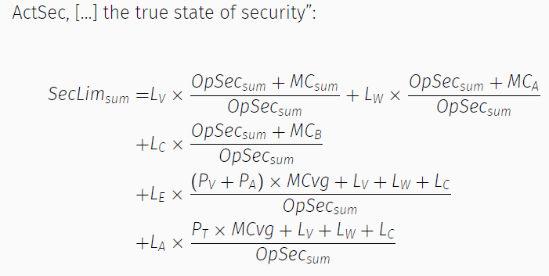

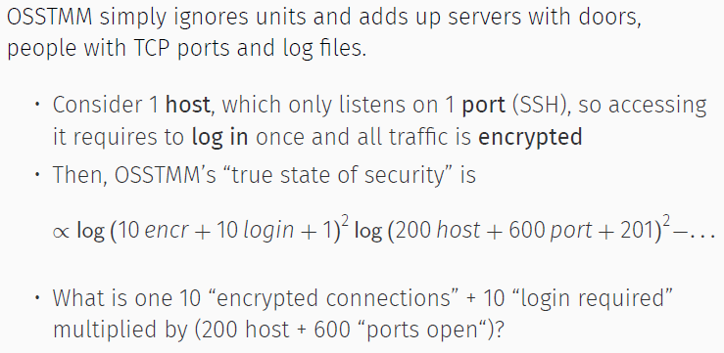

**Critique of OSSTMM**

* Why incorrect and show how OSSTMM fails to deliver on promise
* Carries no meaning about security of considered object
* Shares nothing with trust beside a name
* Makes OSSTMM to conceptualise all human agency as security threat = human security testing approach = reminiscent of a counterin-surgency campaign

**Reflection of pentest methodologies**

* **Contradiction** = Fixing the steps and tests before engaging it, = subvert uds-ing it, methodology NOT adequate for object under consideration
* Often repetitive as targets exhibit large lvl of similarity = permitting to make presumptions about objects (may miss out smt)

Is it worth it?

* What does it mean? – being critical as what you can get

**Information Gathering**

1st stage of pentest, start

* Obtain detailed info about ORG, network, topology, devices, OS
* Project manager to define + refine resources (uds effort, team, skills)
* Whitebox (impt)

Define the team, not rushed, relevant info,

* From several sources,
* build footprint,
* similar to potential attacks,
* impt to uds security posture

Perform in **systematic + accurate** way = avoid missing info

* care when info gathering
* treat all info as restricted

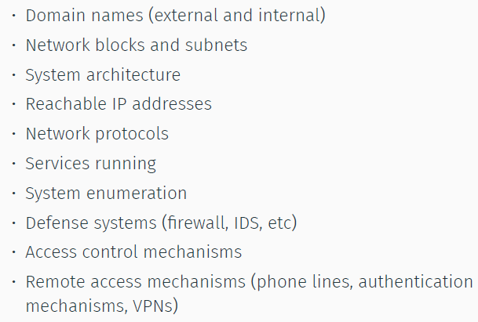

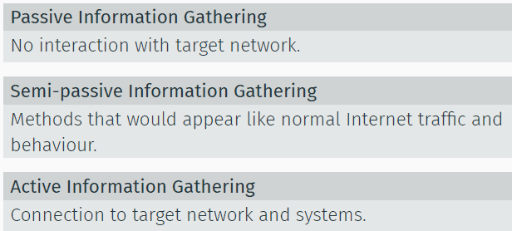

Collection of info (not located in client’s network) = a lot of info in public

* Useful
* Open source intelligence

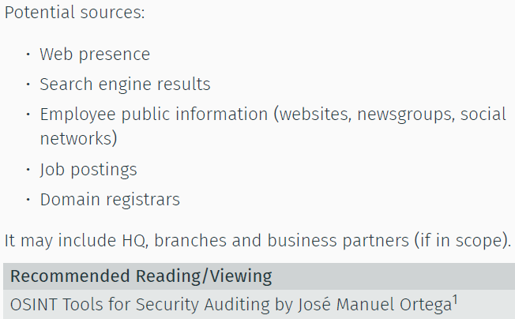

Passive = no direct access

* Can use google cache
* Archieve.org
* Netcraft
* Alexa.com

Active =

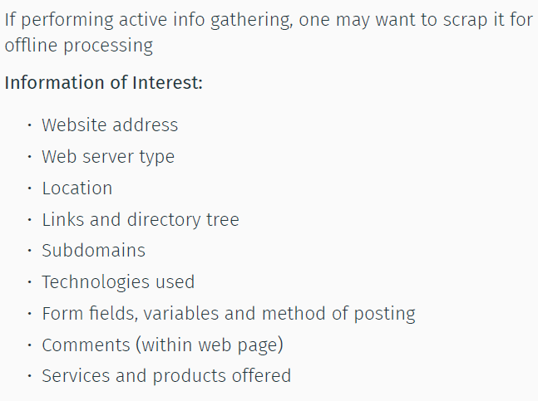

Other info =

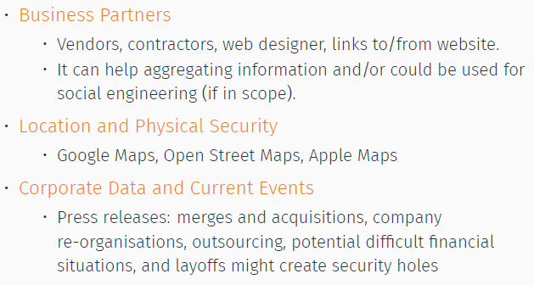

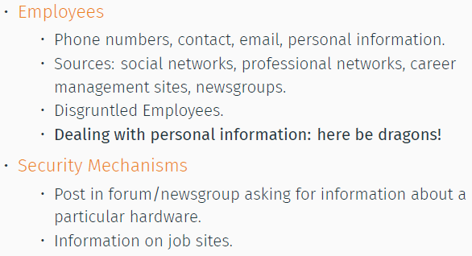

Google Search Engine

* Site:, link:, intitle:, inurl:, filetype:, author:, insubject:
* Google Hacking DB
* Untangling the web

OSINT tools: Maltego, NetGlub

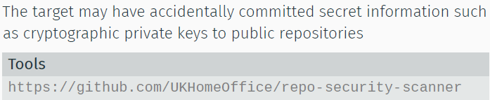

DNS

**EXAM = DNS ENUM VS INTERROGRATION**

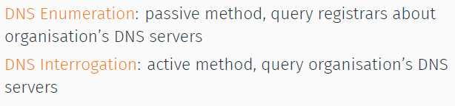

DNS = Distributed DB

* Distributed = no single site knows all info
* Applications access DNS through resolve
  + Provide the IP address
  + Protocol in kernel, no ifo about dns
* Resolver goes to NS to obtain info
* Essential part of internet infra

DNR

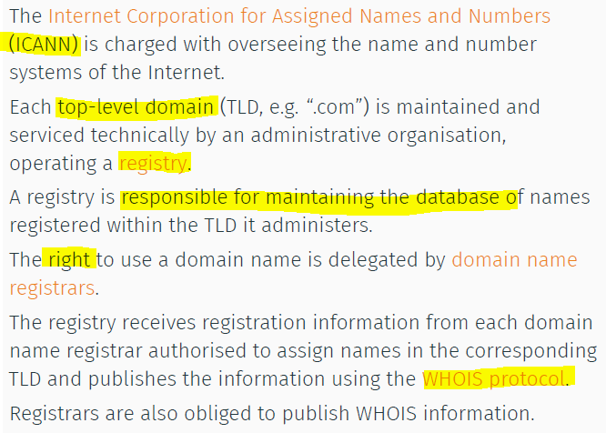

WHOIS

* Query info, TCP port 43
* No trace on target network

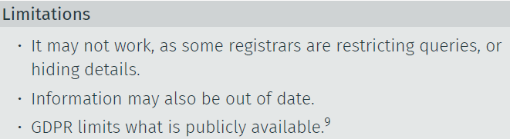

Passive Subdomain Enum

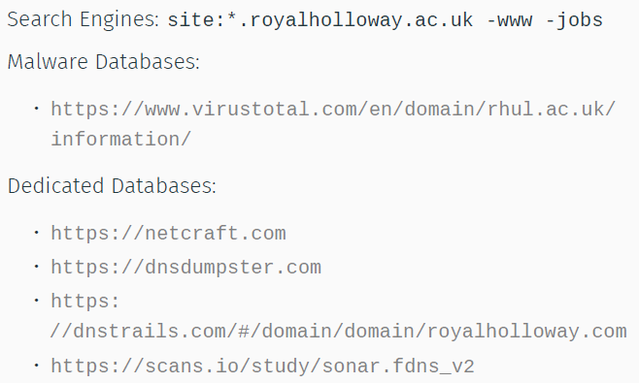



TLS Cert DB:

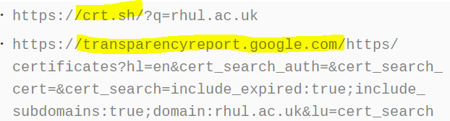

Tools: subfinder

DNS interrogation

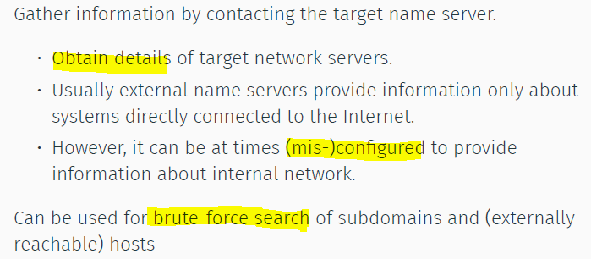

DNS Name space

* Hierarchical
* Tree structure
* Node = label of up to 63
* Zone = subtree

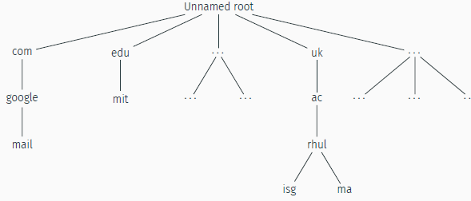

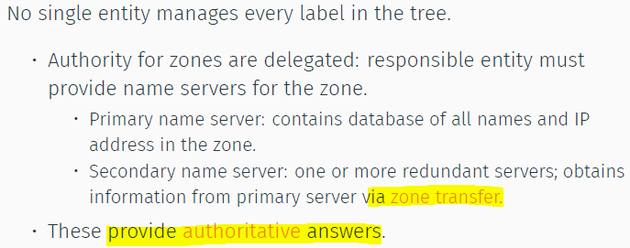

A lot of info, caching = improve efficiency of queries

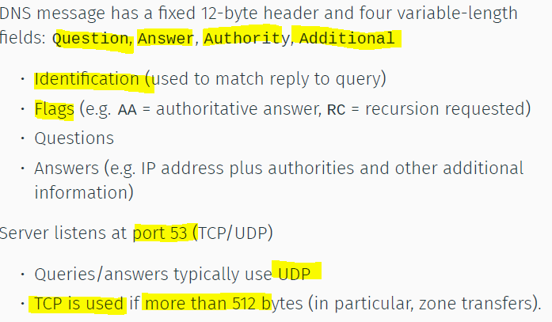

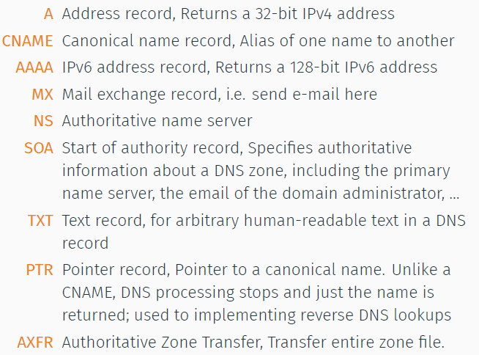

Host, can also use for zone transfer

Host -t axfr zonetransfer.me

Tools: Nslookup, dig

Reverse DNS (IP to domain name)

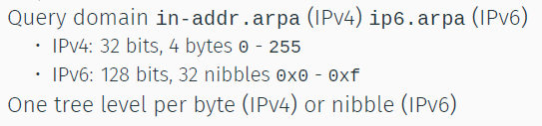

Can you use reverse DNS to search for all?

No as: it’s not 1-1 mapping, may point to outside IP (not in the range),

* Tools: Amass

DNS Walking:

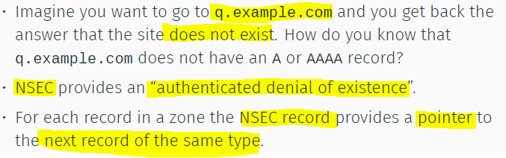

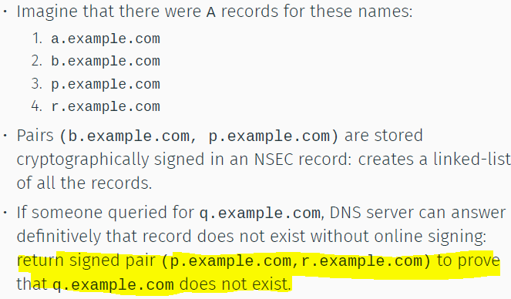

* Dig signature of dns records = too much.
* Walk through the domain, LAST -1
* Dnssecwalk = nsec enum
* NSEC3 = hash the name and sort hash lexicographically. Atk = find all legal hash, then do offline dictionary atk
* NSEC5 fixes that

DNS Cache Snooping

* Using RD(recusion desired) = 0
* Gets all the cache, if u bruteforce
* Can get surfing habits of the ppl in the network

DNS Tunnelling

* Iodine = tunnel IPv4 through DNS server.
* DNS reply = contain a kilobyte of compressed payload data

DNS Streaming

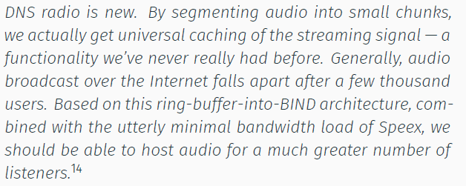

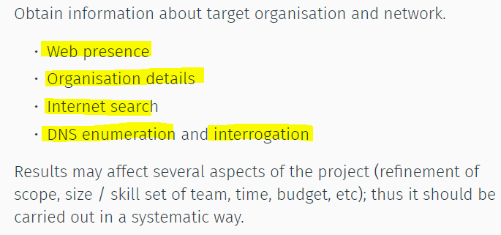

**Target Discovery**

Goal = probable network topo

* Perimeter network identification
* Live internal hosts
* OS fingerprinting

Performed mostly by communicating directly with target

Network protocol needed TCP, IP, ICMP, UDP, HTTP,

Routing protocol = OSPF GBP

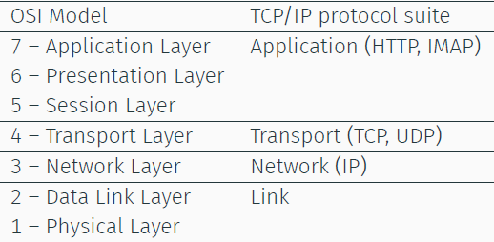

Link layer:

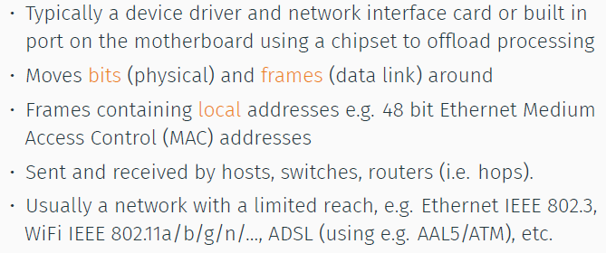

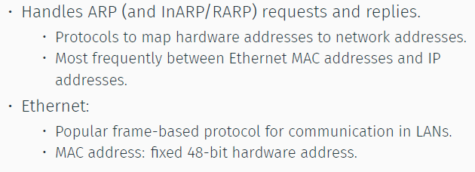

WIFI:

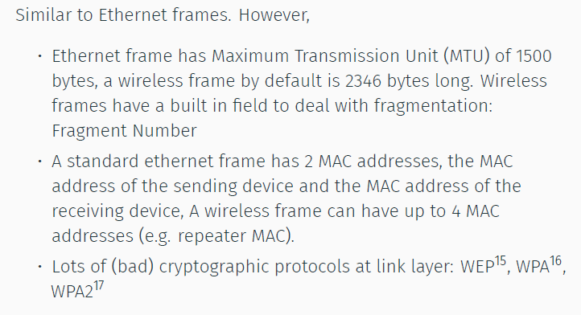

VLAN: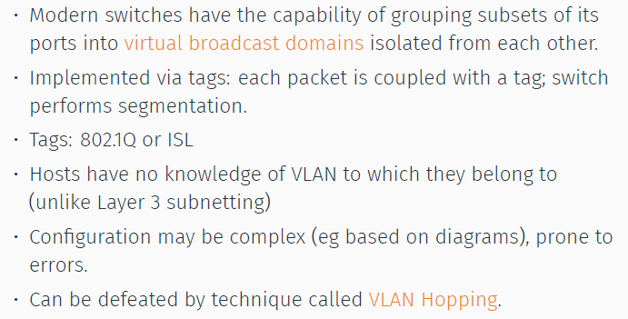

ARP:

ARP:

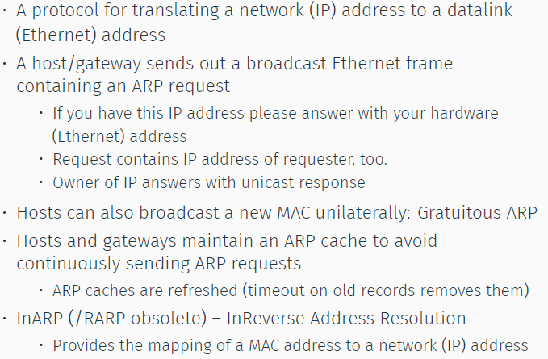

ARP-Based Host Discovery:

Listen to ARP requests, Send ARP Requests   
(Both requires to be on lan)

ICMPv6 = neighbour discovery

ARP Poisoning

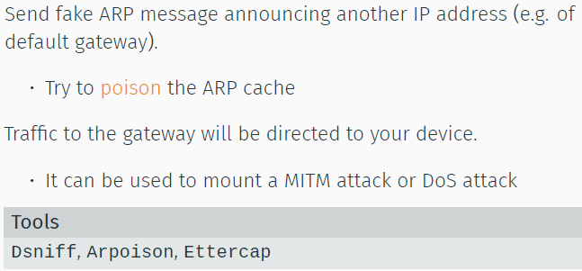

Network layer:

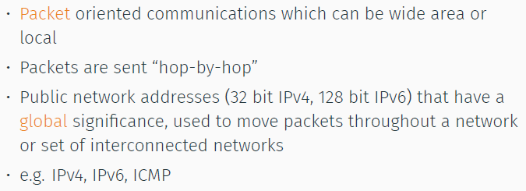

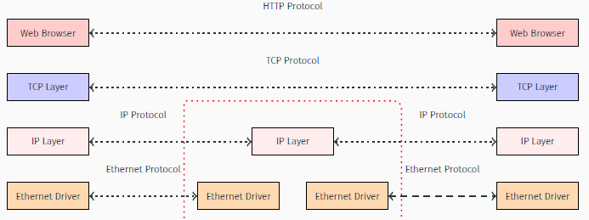

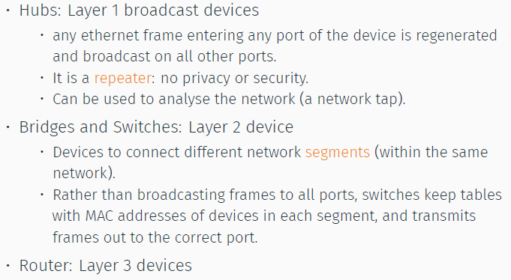

IPv4:

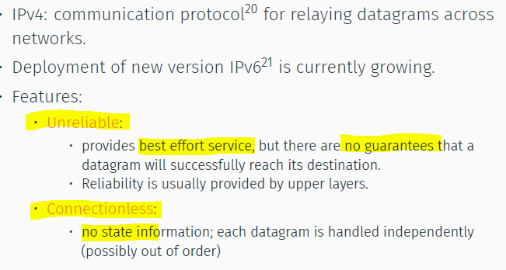

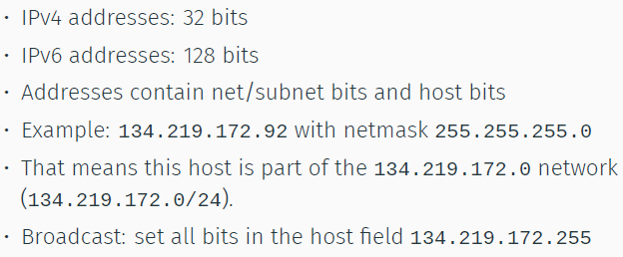

Can you search all IPv4/IPv6 ? IPv4 possible, IPv6 = impossible, or else we can crack AES128

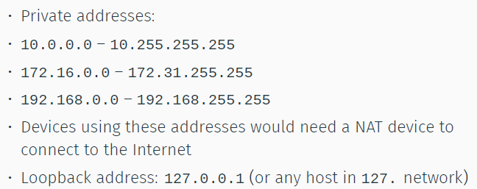

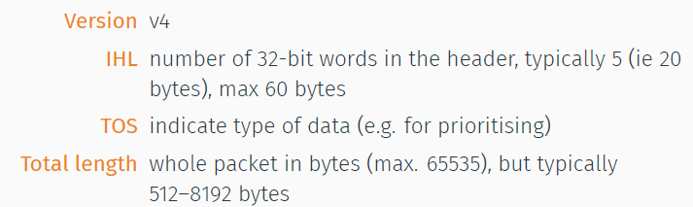

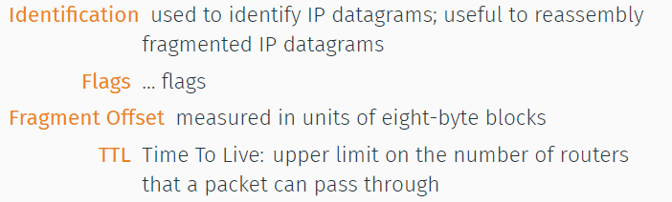

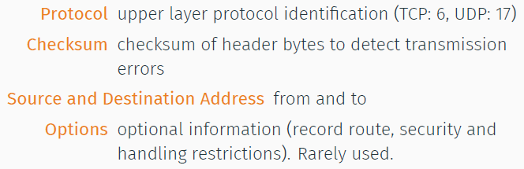

IP Routing:  
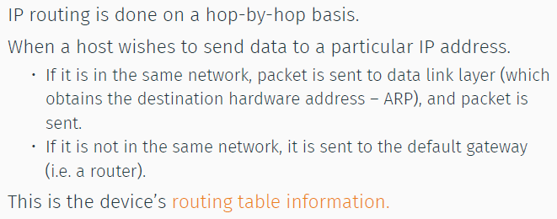

Routers – forward data packets,

Routed from source -> destination

* Decision = routing table info
* Routers = OSI layer 3 (network device)

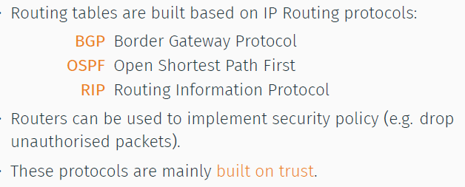

BGP

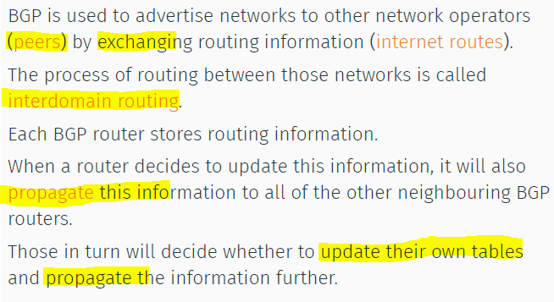

No protection against attacks that modify/delete/forge/replay data

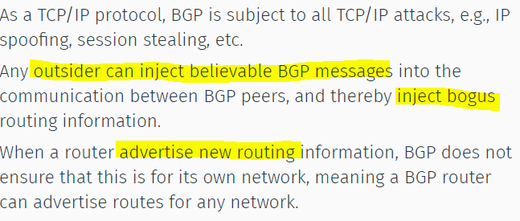

TTL = decrease by 1 from each router

* Prevent package from ending up in infinite loops

Different OS = use different TTL values

ICMP – part of IP. Query device, communicate error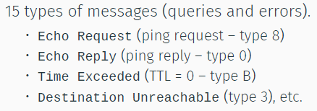

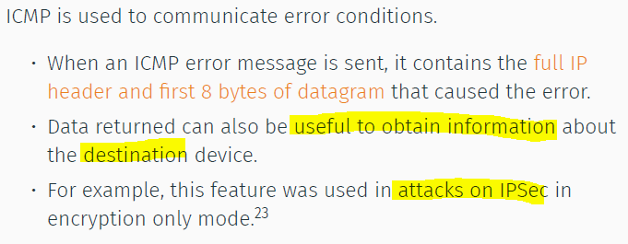

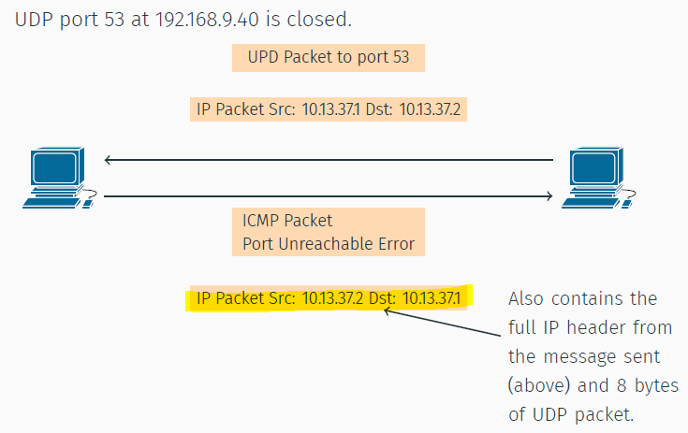

Ping of Death

Host Discovery:

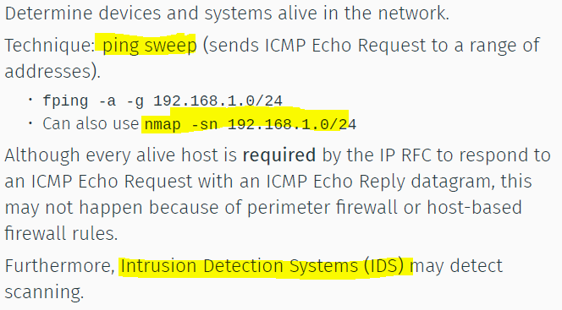

Cant rely on ping

Can use ICMP Timestamp Request, or ICMP Address Mask Request instead (if got shitty blocked)

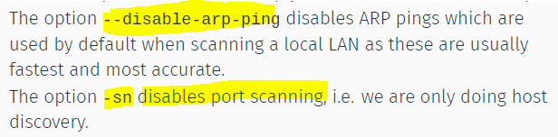

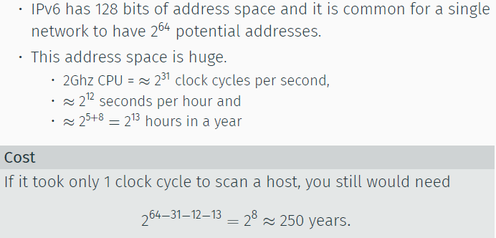

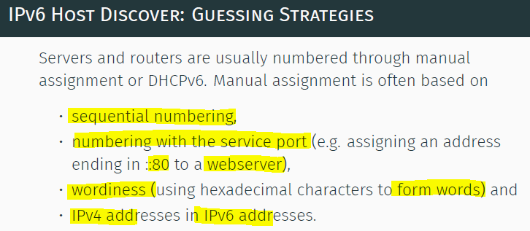

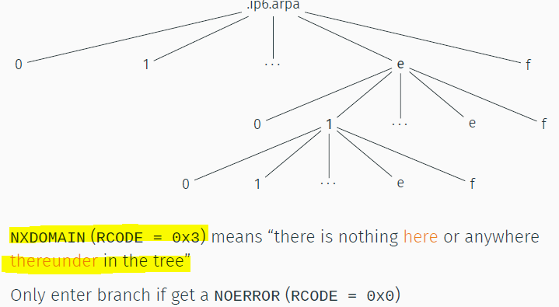

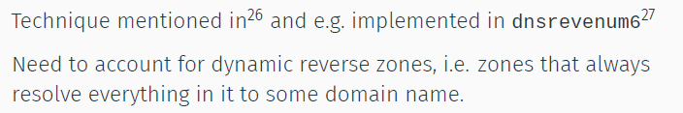

Traceroute = send info about itself if TTL is 0

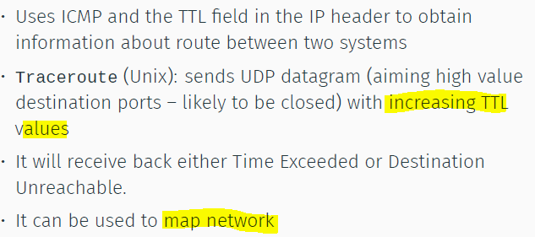

Traceroute lies = duno how to send back, and hop another way back, coming back from another route

Network topo,

* Build a map/diagram of network
* Traceroute is your friend :D
* Network may block UDP/ICMP (can use tcptraceroute)

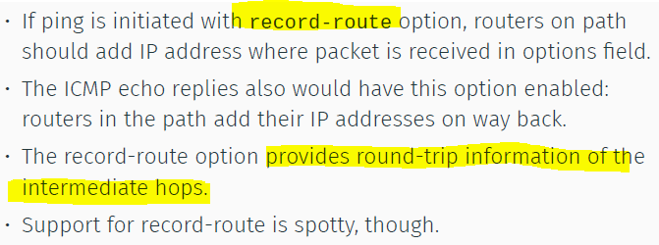

UDP = simple, datagram oriented

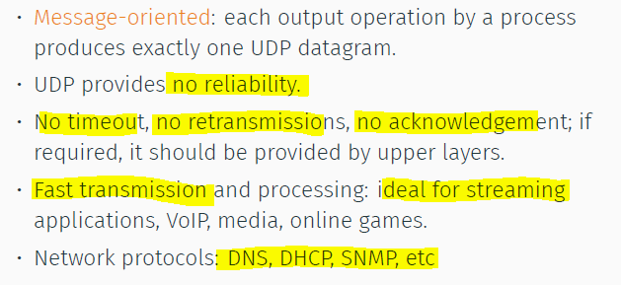

UDP = 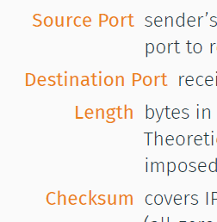

Ports= TCP / UDP

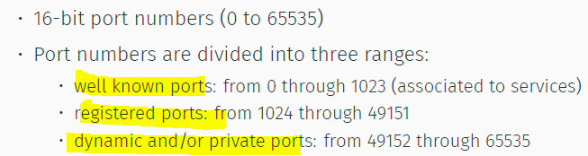

TCP

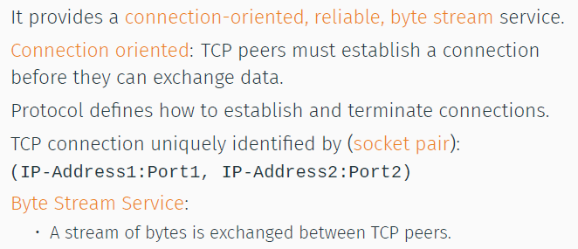

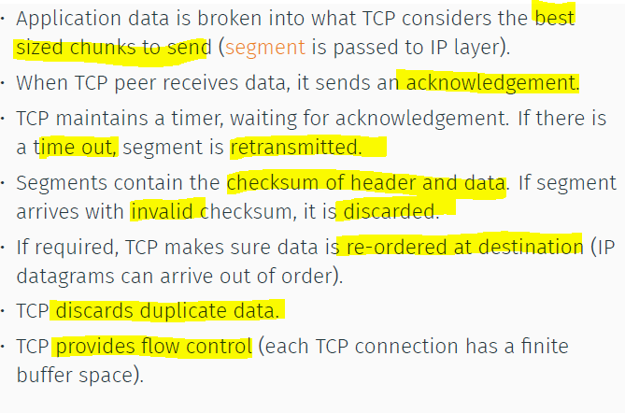

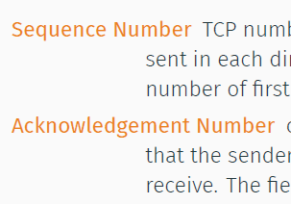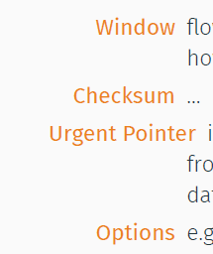

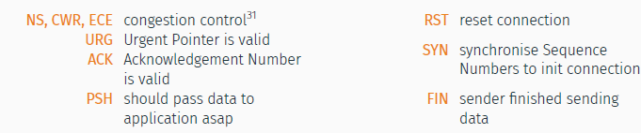

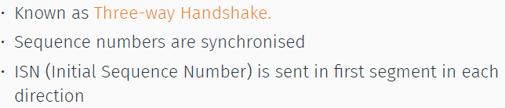

SYN, SYN-ACK, ACK

FIN ACK, ACK, FIN-ACK, ACK

RST = if not correct. Connection request to closed PT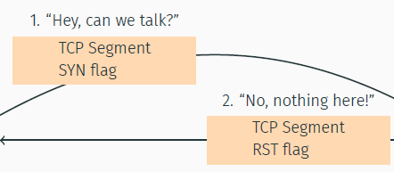

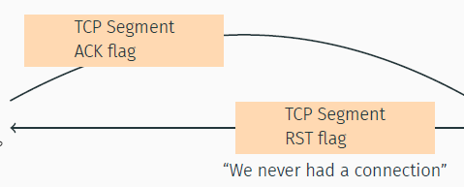

**TCP SYN Scan:**

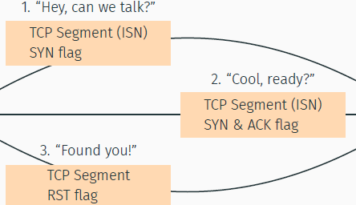

RST = closed, SYN/ACK = open

**TCP ACK Scan:**

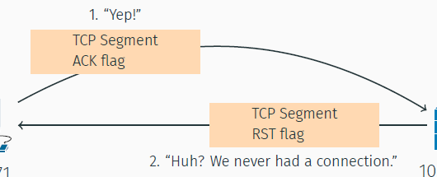

UDP PING:

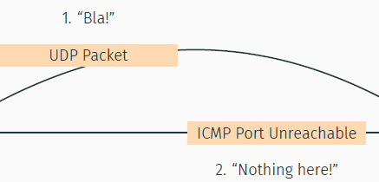

If opened, it will be dropped, unreachable if closed

NMAP:

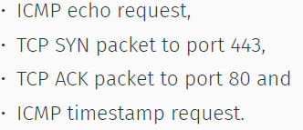

SYN = will usually block

ACK/ICMP timestamp = not so commonly blocked

OS Identification

Different vendors implement TCP/IP stack in recognisable ways.

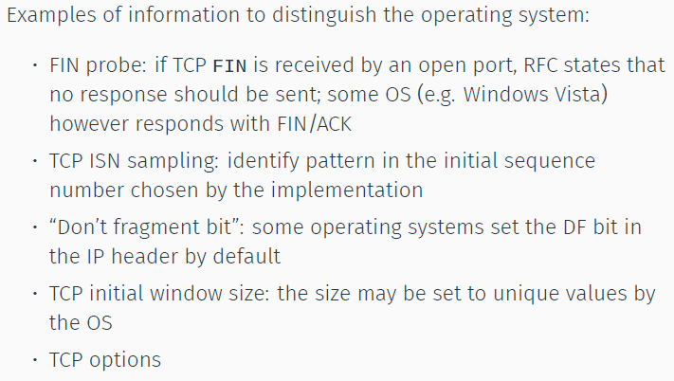

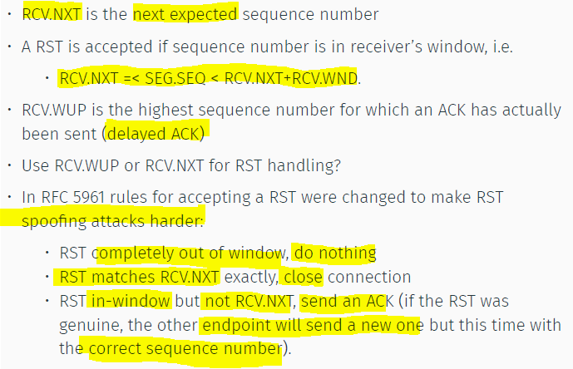

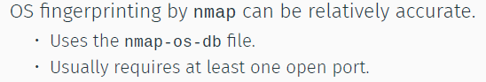

Passive OS Fingerprinting

- Based on TTL value, Windows Size, Don’t Frag Bit

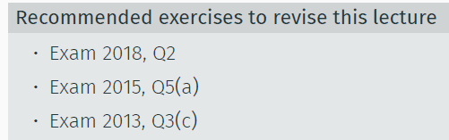

**ENUMERATING TARGETS**

Port scanning = send packets to TCP/UDP ports

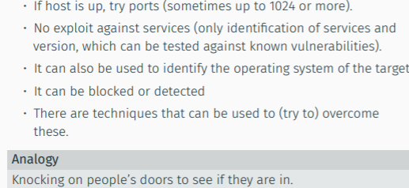

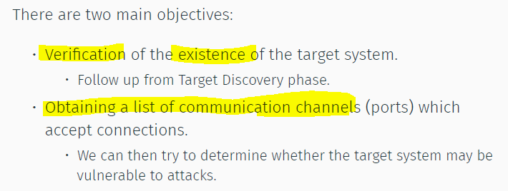

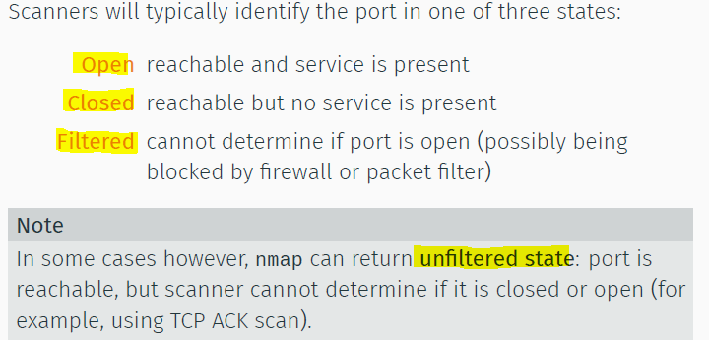

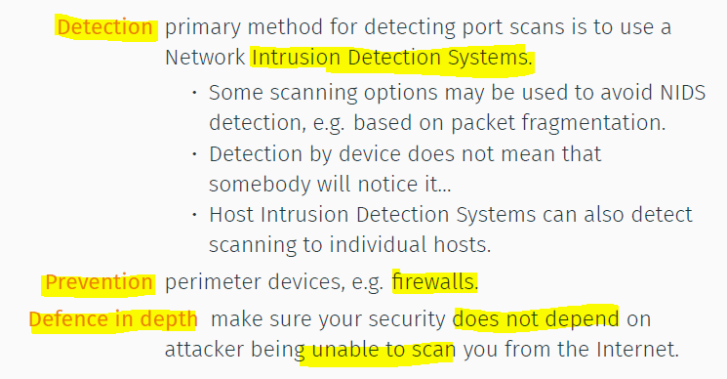

Firewall

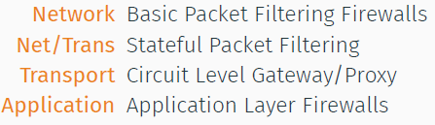

**Packet filtering:**

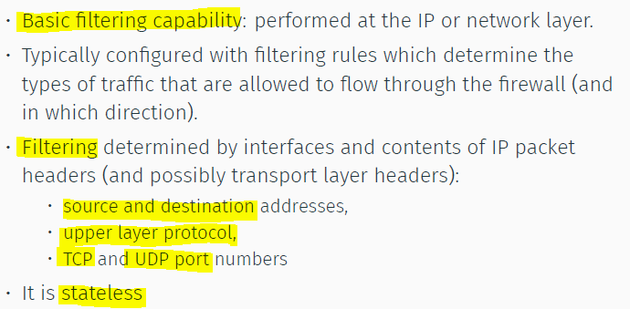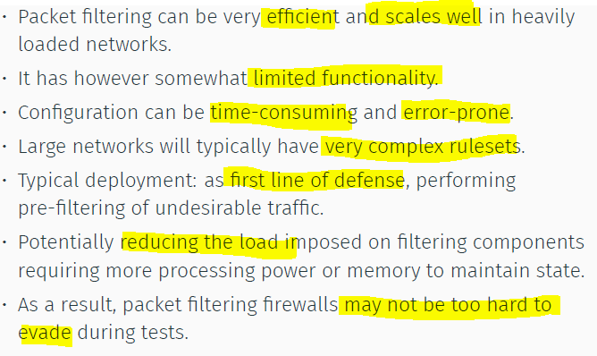

**Stateful Packet Filtering**

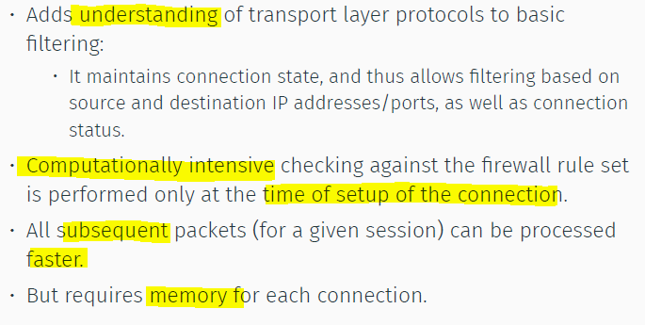

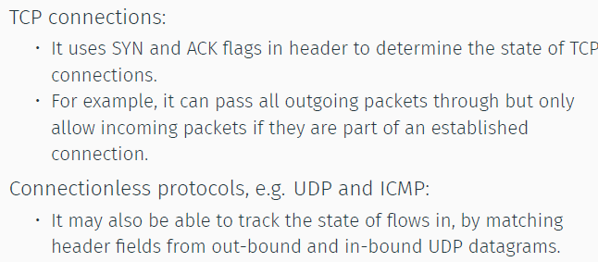

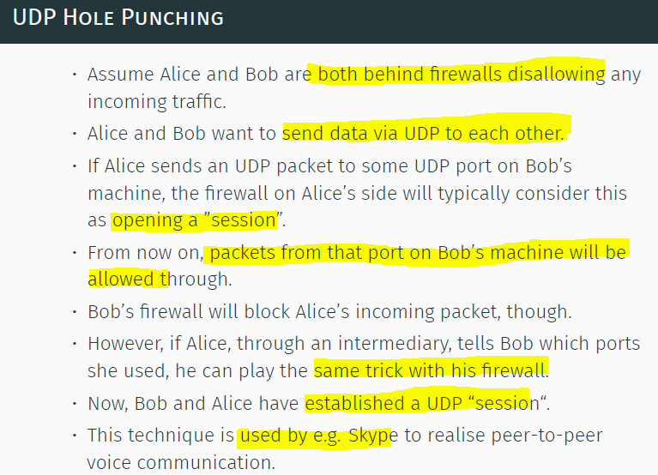

**Circuit Level Gateway/Proxy:**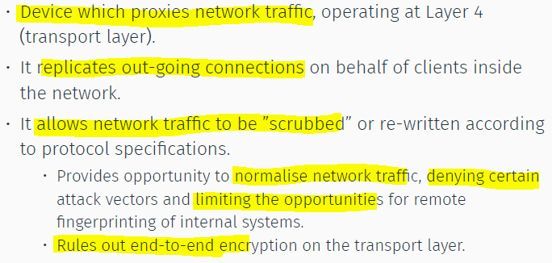

**Application Layer FW:**

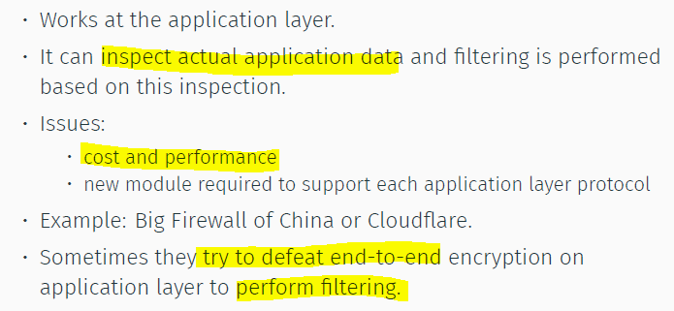

**Scanning Blocking + Detection:**

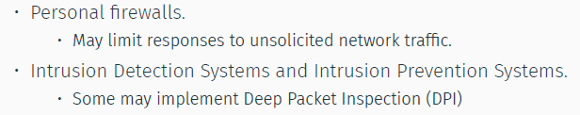

**Network Sec Devices Issues:**

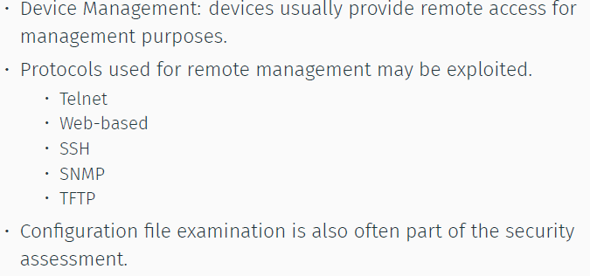

**Bypass FW:**

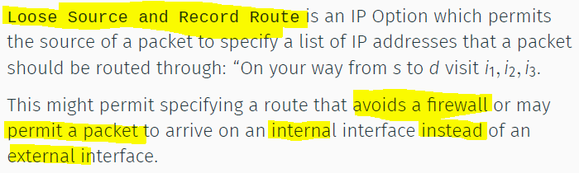

**TCP SYN Scan:**

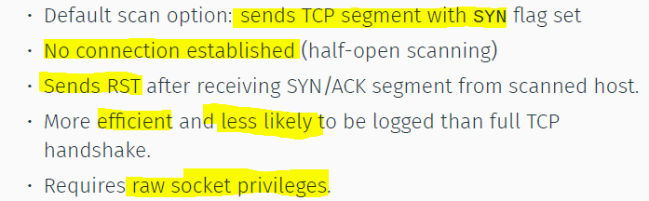

**TCP Connect Scan**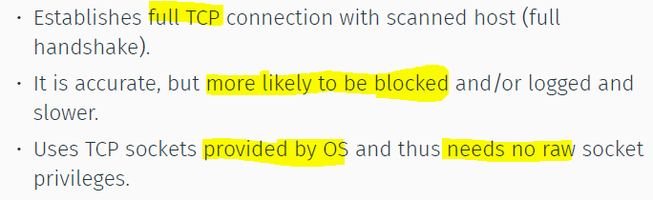

**UDP Scan:**

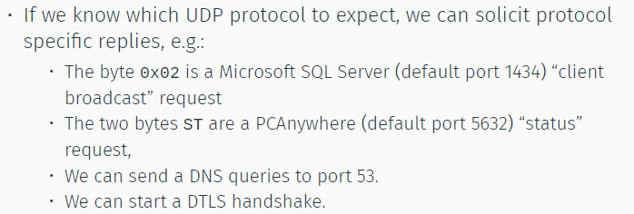

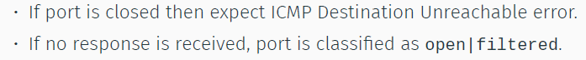

* It’s slow as there is rate limiting on error messages

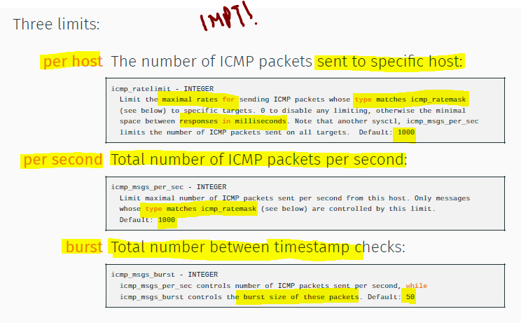

**ICMP Rate Limiting:**

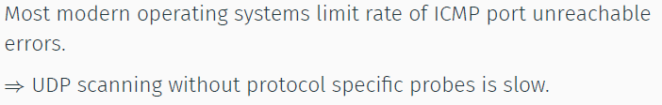

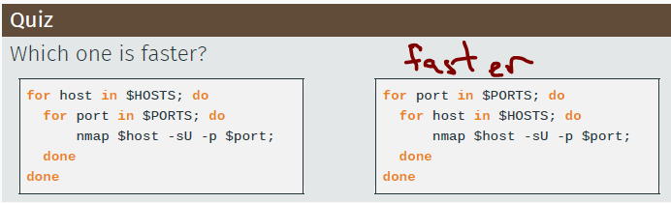

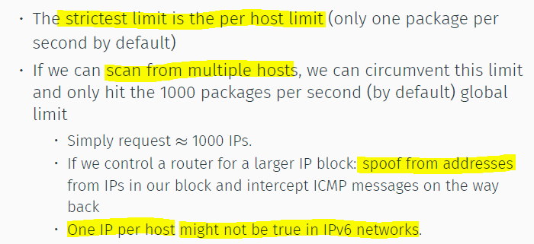

**Scan Timing:**

* **Avoid IDS detection**

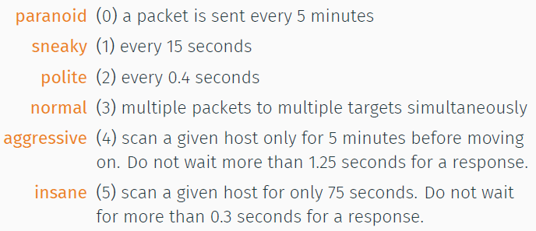

**TCP Filtering Detection Scanning**

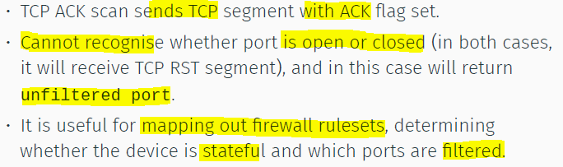

**Filtering Avoidance:**

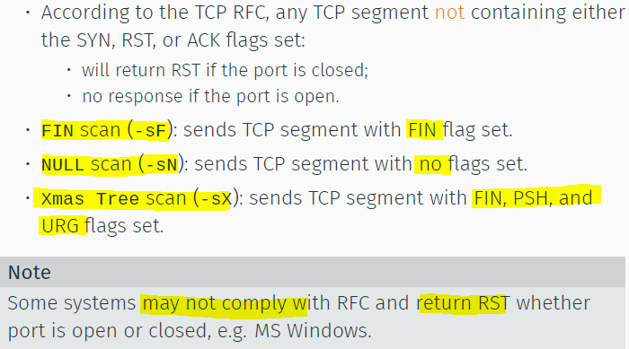

**Using Packet Fragmentation (Tiny)**

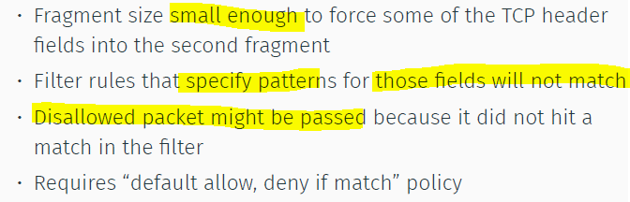

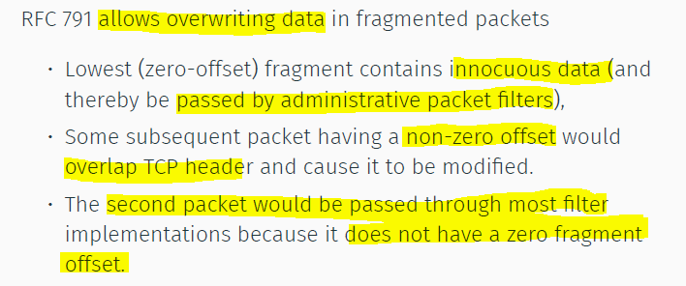

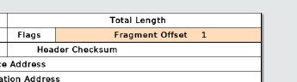

**TCP Stealth Scan:**

**Using predictable IPID (**for IP Fragmentation**) to know if ports is open.**

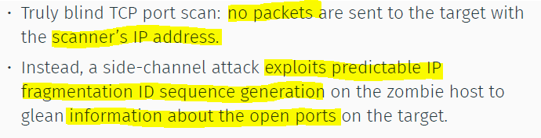

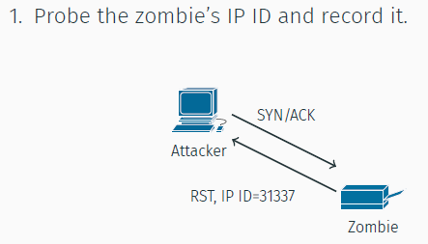

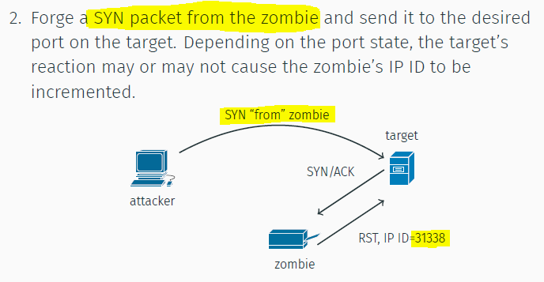

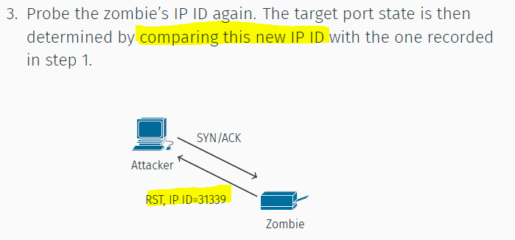

**Large Scale Scanning**

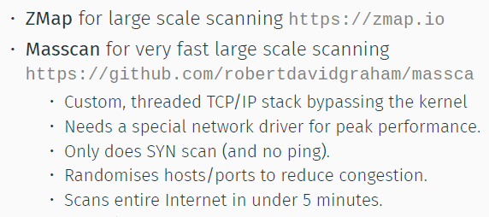

**UDP Stealth Scan**

* No packets sent to target
* Exploits ICMP Rate Limit.

3 Hosts:

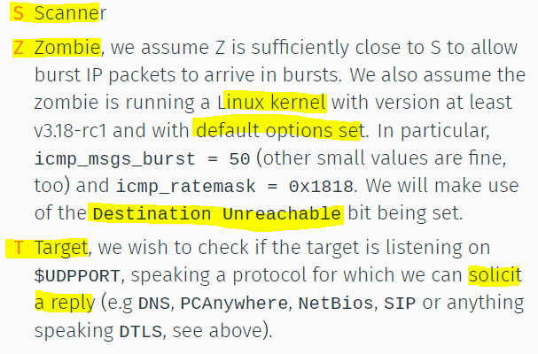

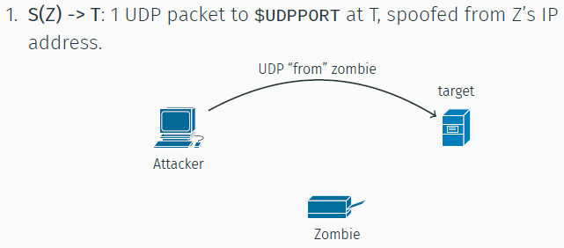

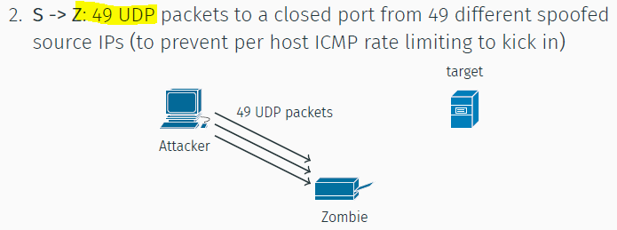

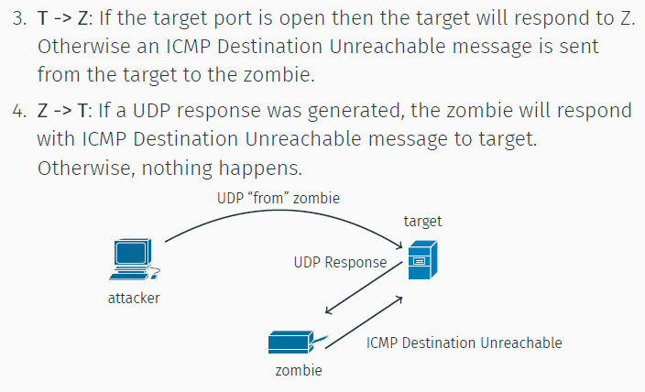

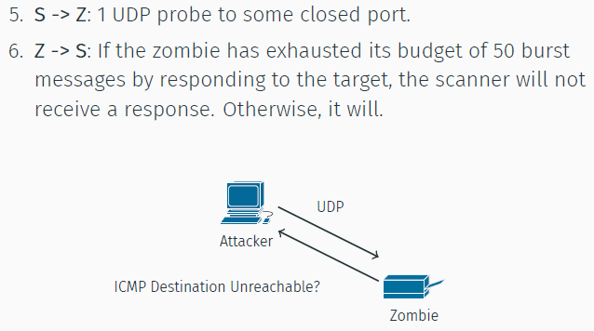

Spoofing

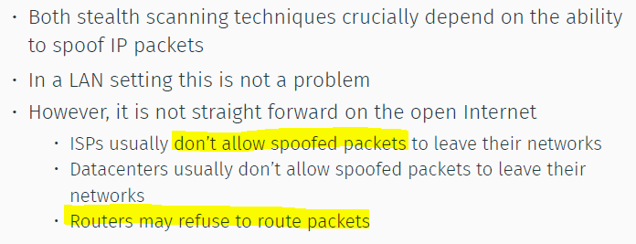

NetBios Scan

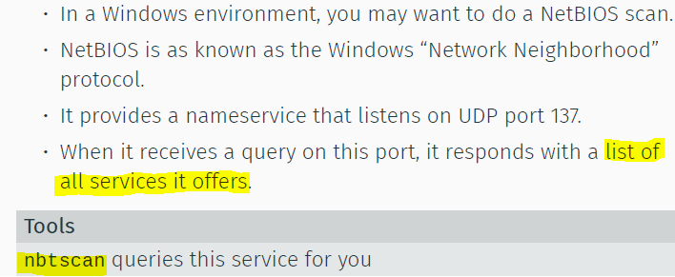

Summary

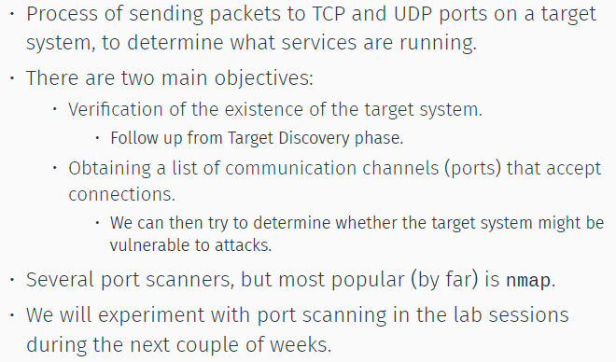

**Service and Vuln Identification**

Banner Grabbing

* Info about services
* Use nmap -sV --script=banner
* Use ZGrab <https://github.com/zmap/>

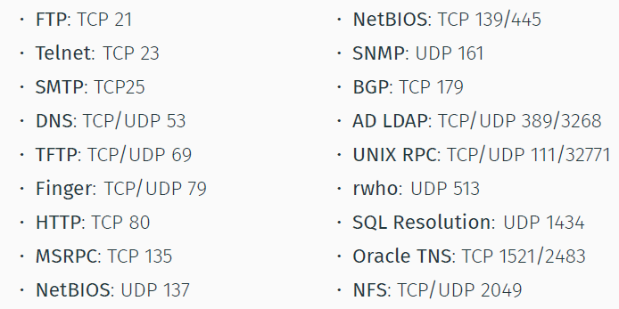

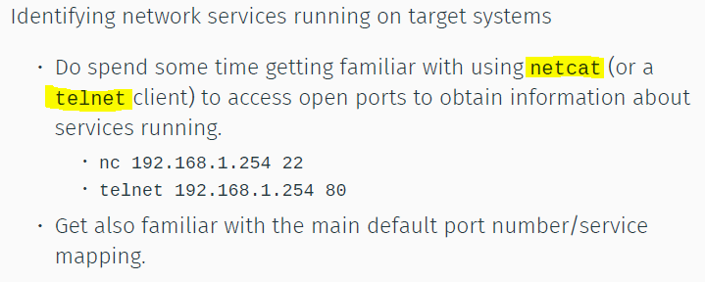

Passive scanning = Shodan + Censys

Security Vuln

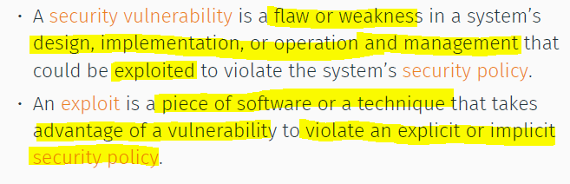

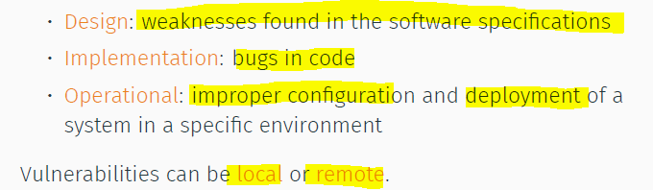

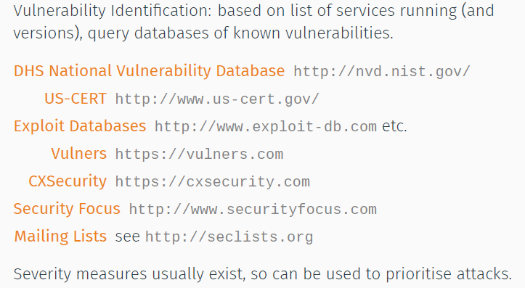

CVE = common vulnerabilities and exposure

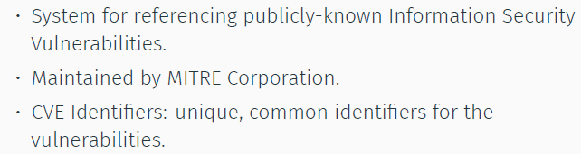

Zero-Days

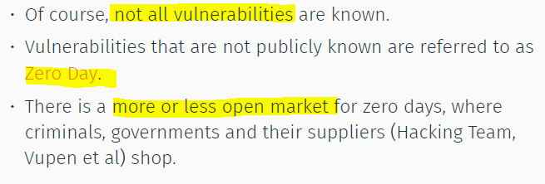

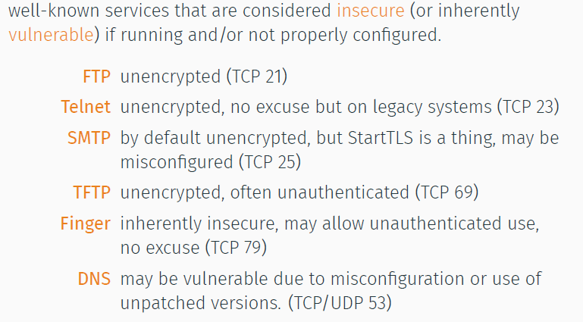

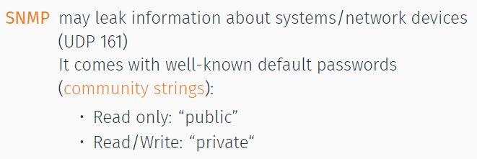

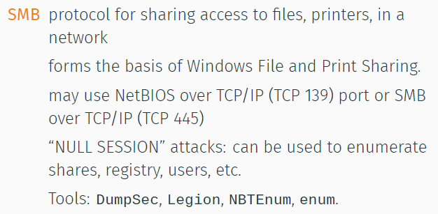

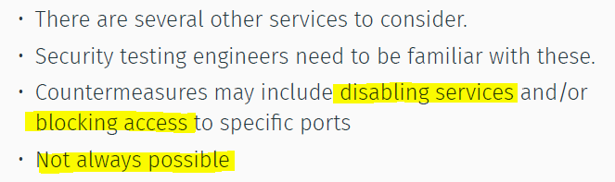

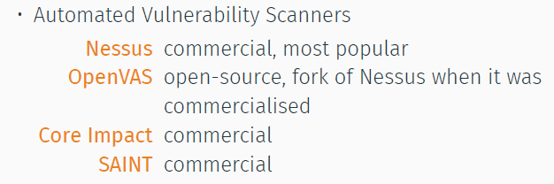

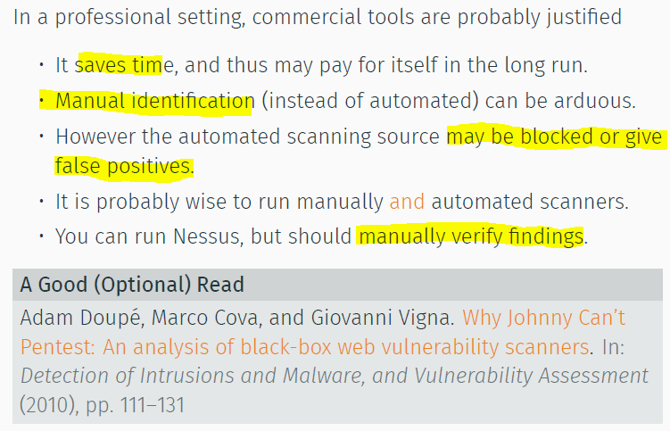

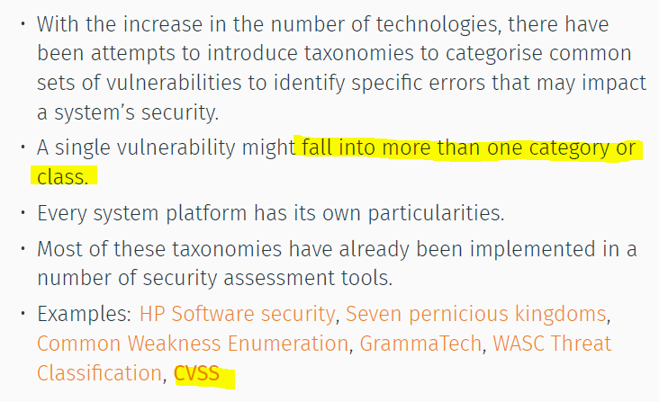

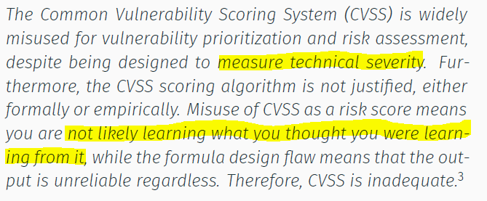

**Target Exploitation**

Vuln Verification

* Mostly risk assessment, no proper atk

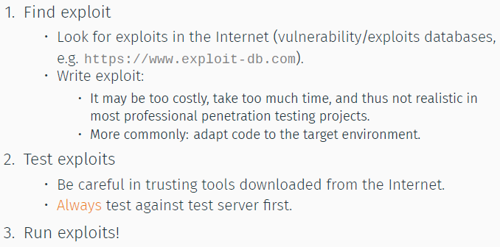

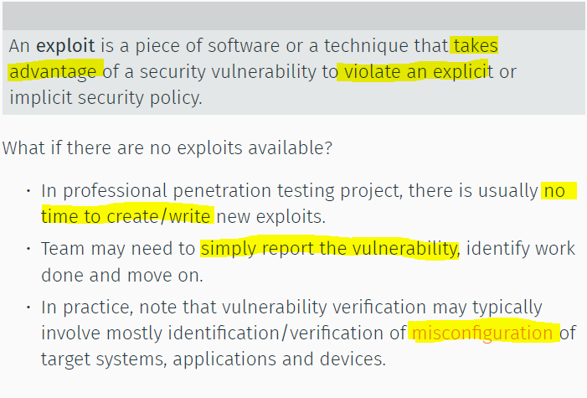

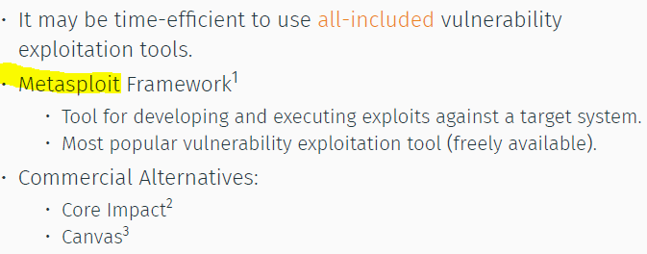

Other attacks:

Default creds, bruteforce auth, exploit software vuln (or fuzzing)

Default Creds:

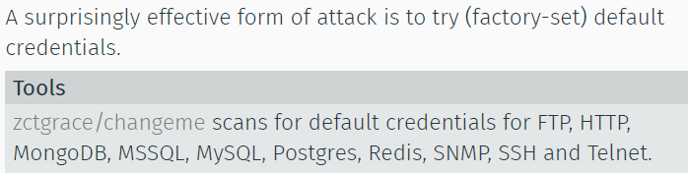

Bruteforce:

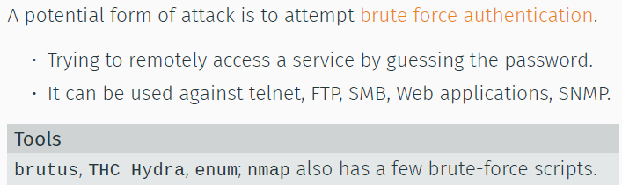

* Simple, easy to detect/protect, may be possible due to misconfig

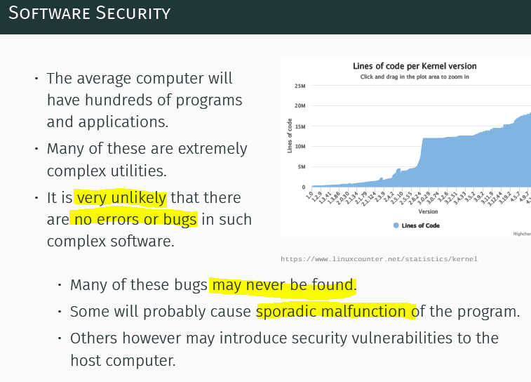

Software vulns result of:

* Assumption by devs on env
* Programming errors

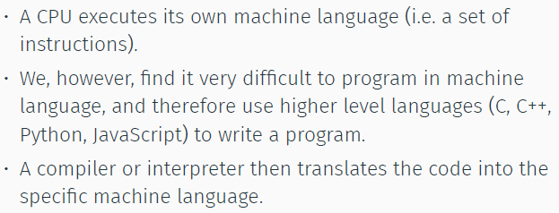

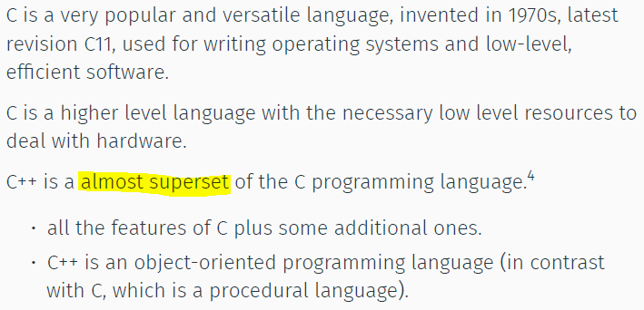

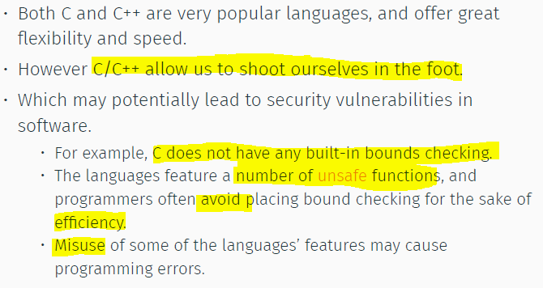

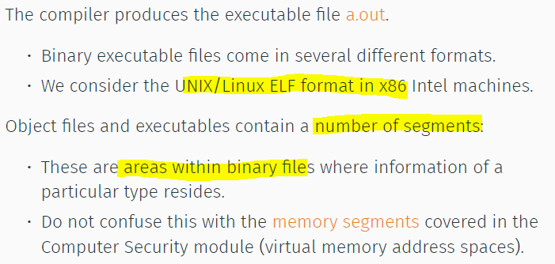

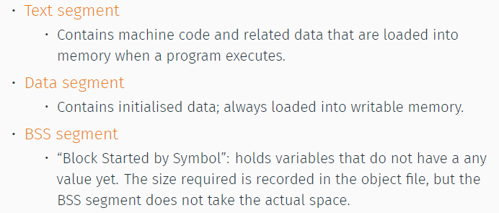

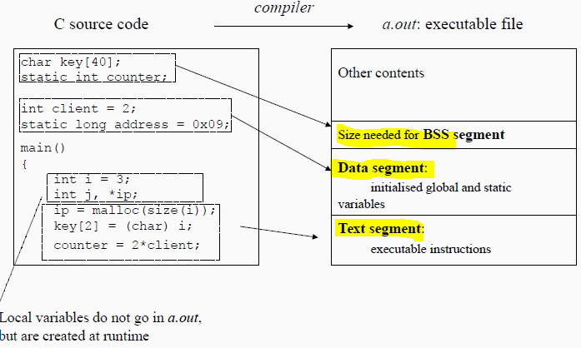

Test segment = readonly

Data = initialised + static var with assigned values

BSS = block zero-ed

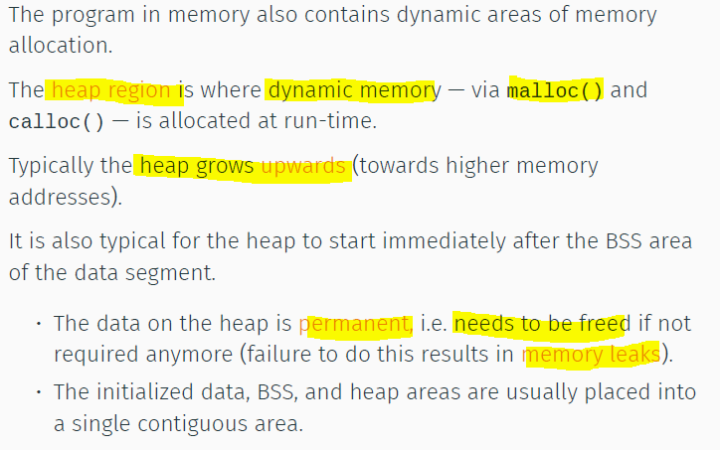

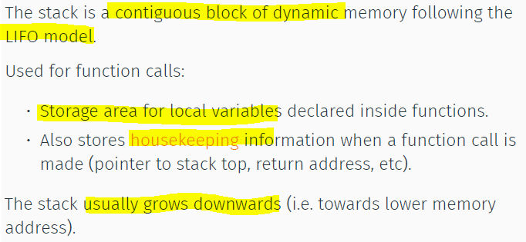

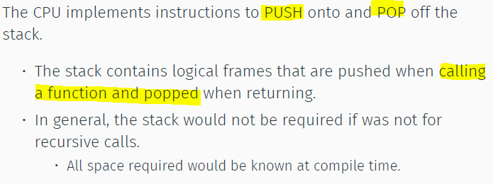

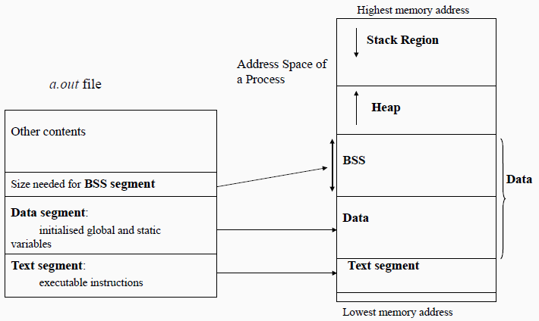

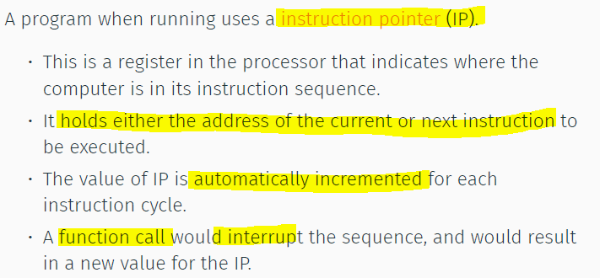

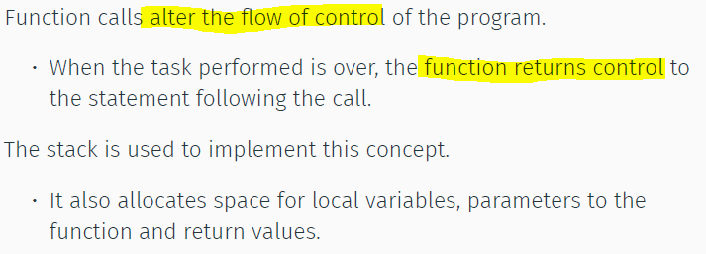

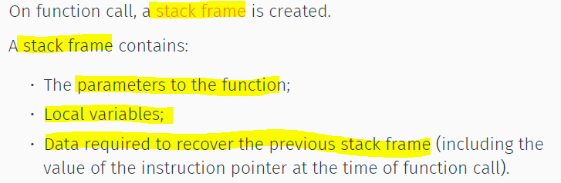

Frame pointer = fixed location.

Local var = offsets from FP

* Needs to save the previous value of FP, so can restore.
* Then a new val for FP, for new stack frame

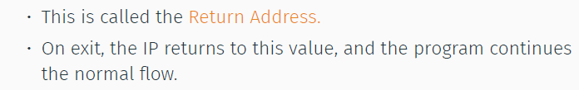

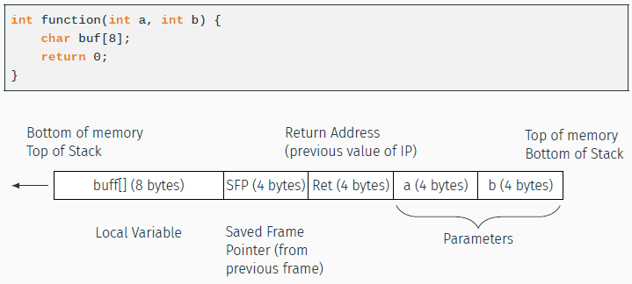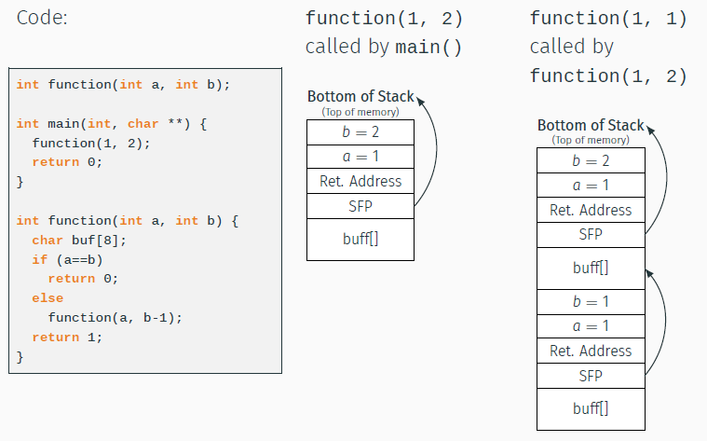

Buffer Overflow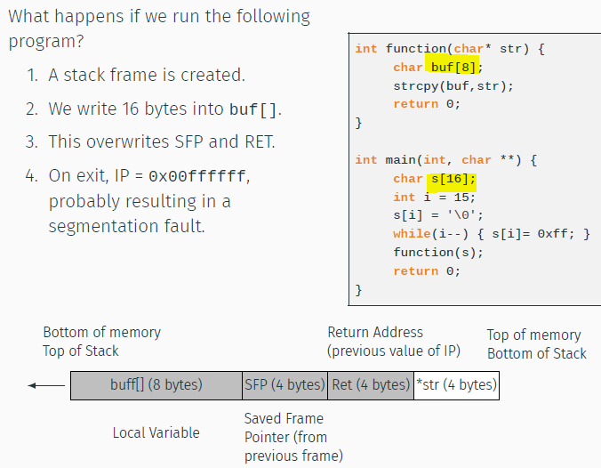

Will result in malfunc

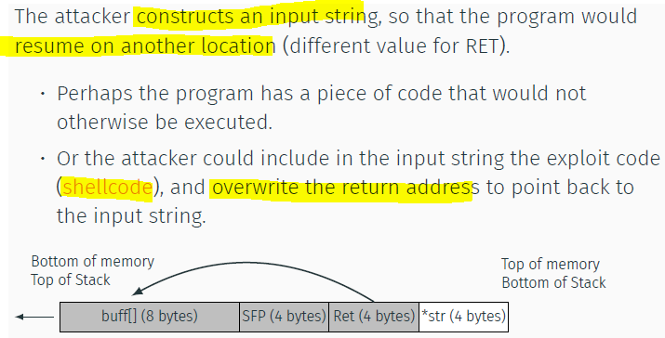

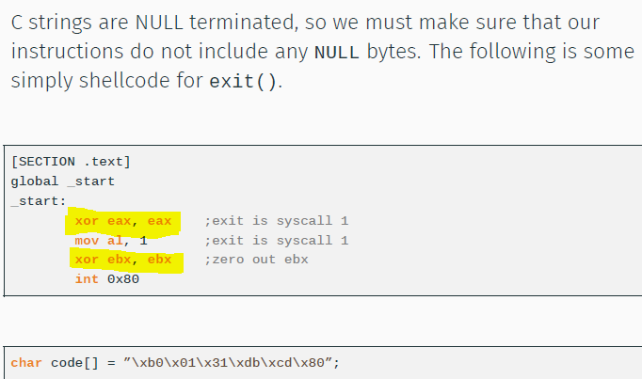

Mitigating BufferOverflow

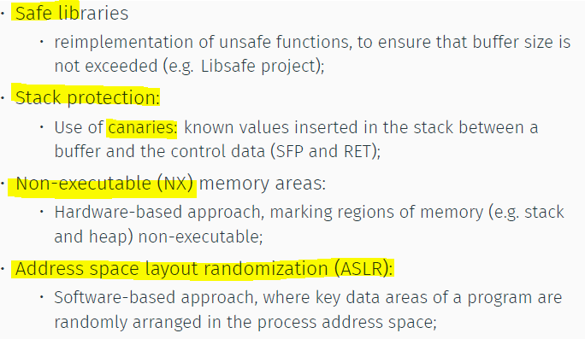

Defeating defences  
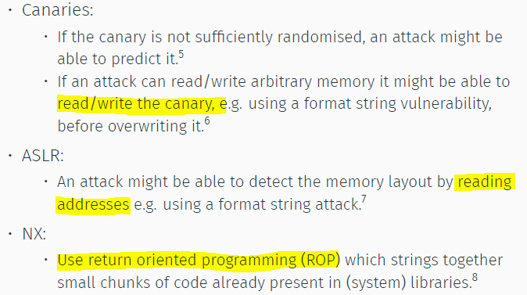

Integer overflow

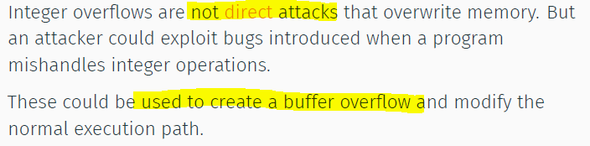

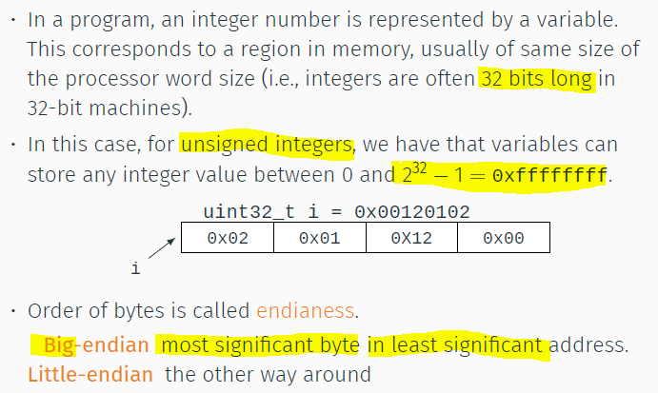

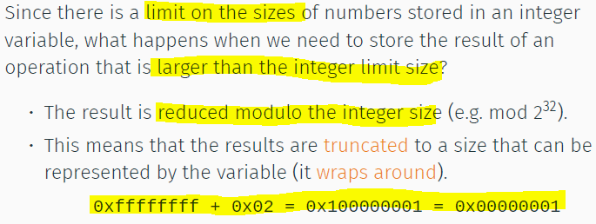

Exploiting integer arithmetic overflow

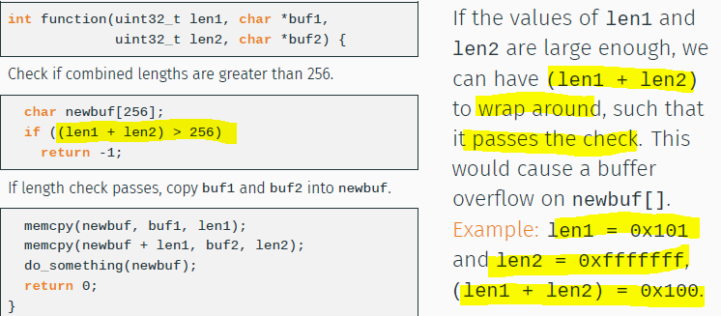

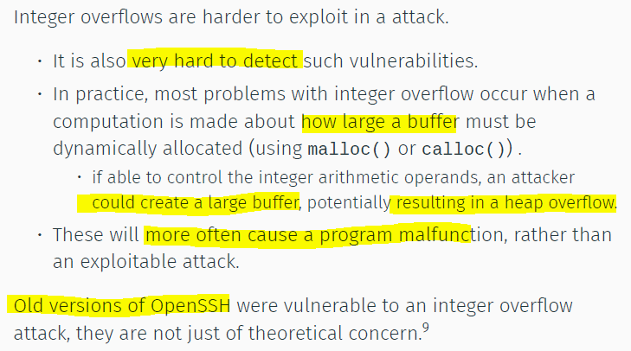

Buffer Overrread = Heartbleed

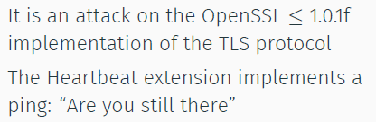

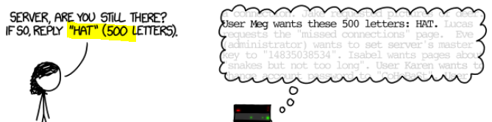

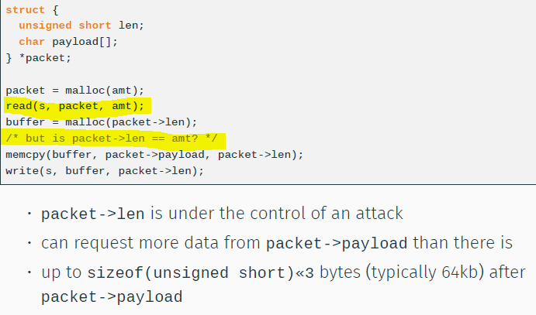

Summary

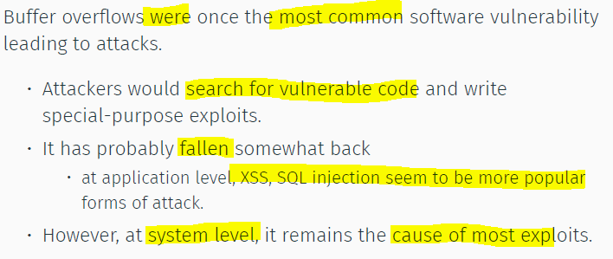

Mix Data and Control in same channel

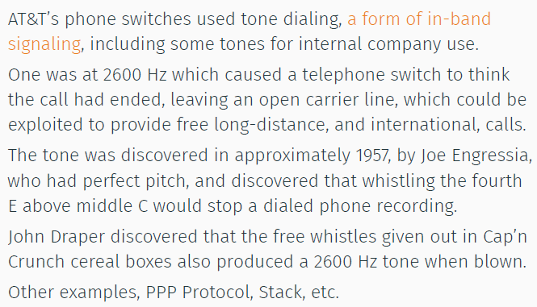

Format String Attack  
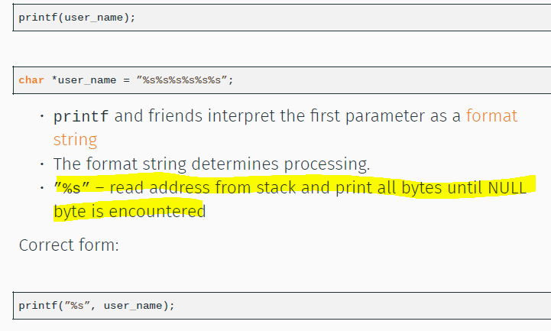

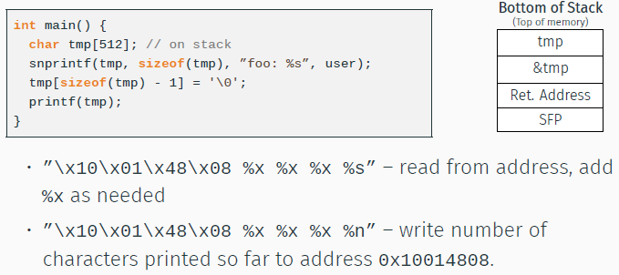

In Python,

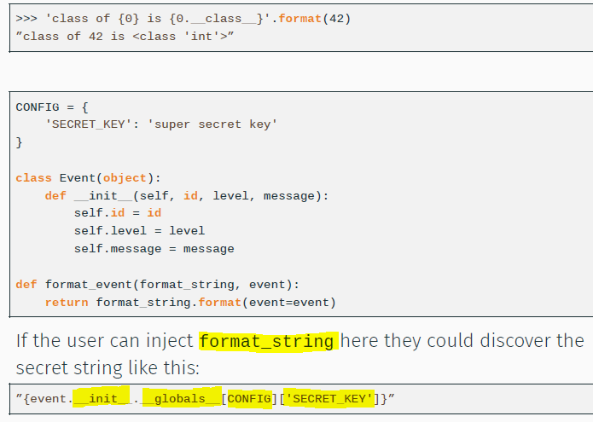

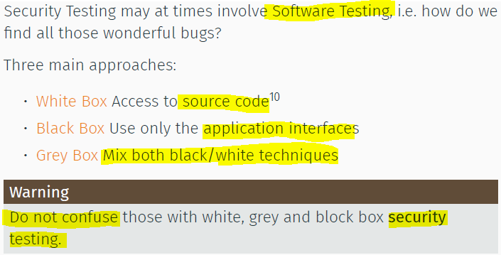

White code = Source Code Review

Grey Box = Binary Auditing, RE, Disassembler, Decompiler, Deubggers

Blackbox using the system interface

* Functional testing: against req specs
* Robustness: generates ill-formed test case to verify reliability, + security

Fuzzing

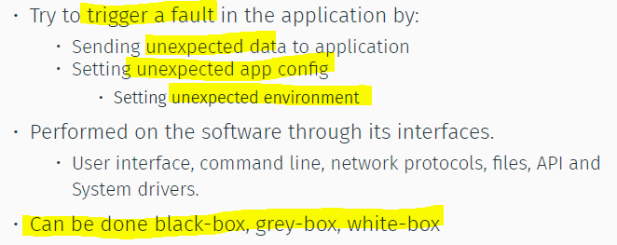

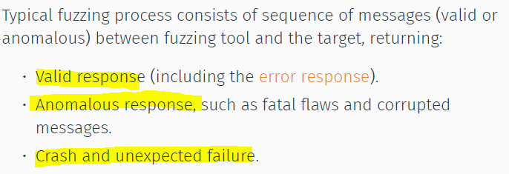

Types of fuzzing

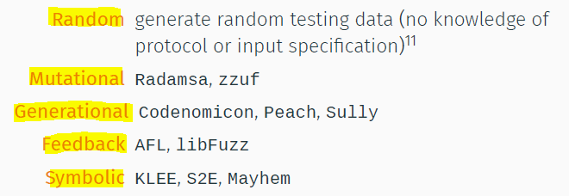

Mutational

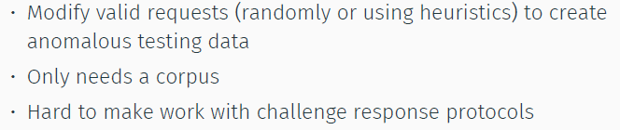

Generational

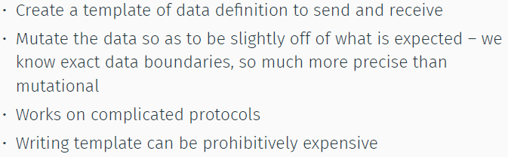

Feedback Fuzzing (just observe, no reasoning)

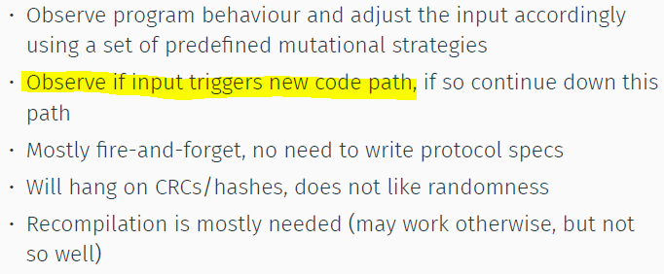

Symbolic Exec (reasoning the inputs to go to other branch)

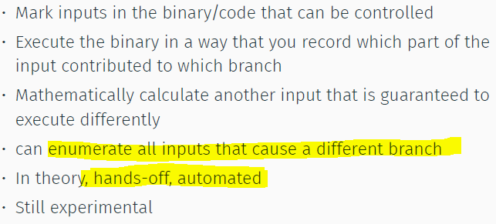

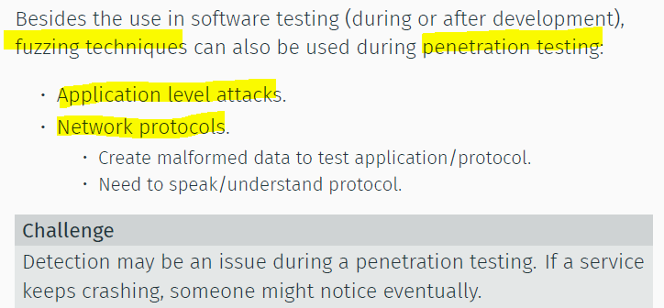

Bruteforce Exploit Detector (BED)

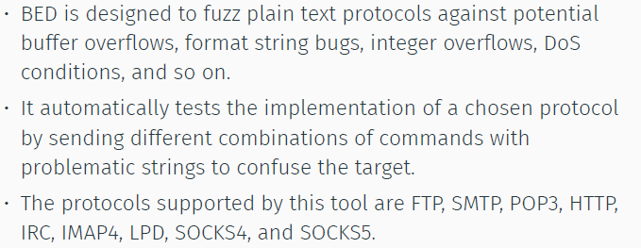

JBroFuzz = java based stateless network protocol fuzzer

AFL(American Fuzzing Lop) VS READELF

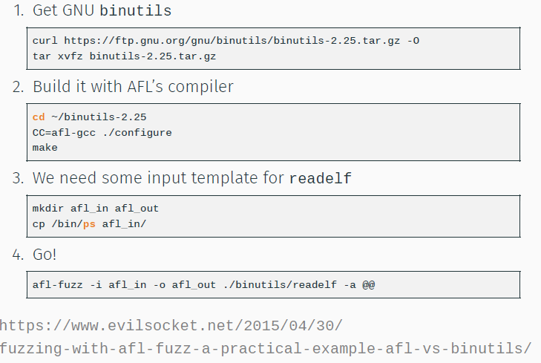

Project Mgmt Issues

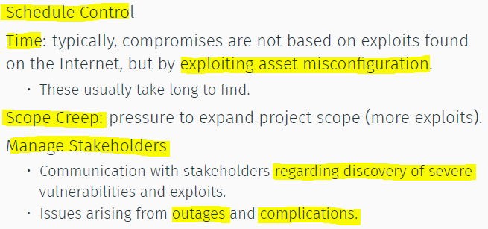

Web App Security Testing

Should start with SDLC

Web based = effective

* Accessible
* Complex (more errors)
* Great availability of data
* High impact (downtime, data leakage, rep)
* Misconfiguration

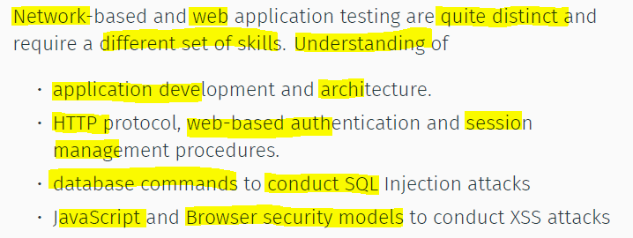

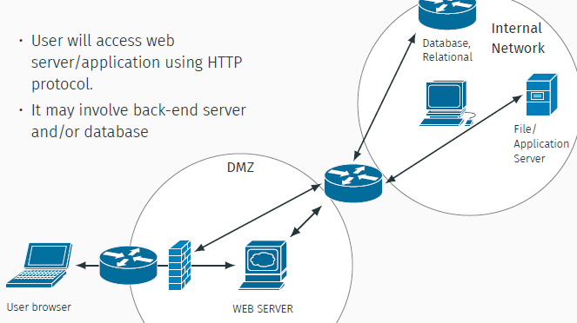

Server side

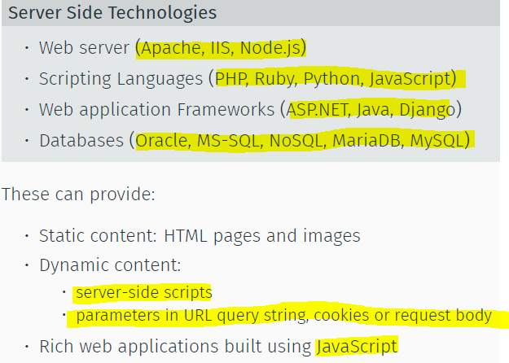

Client Side

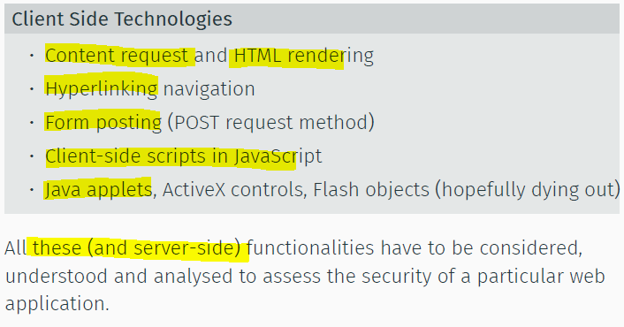

HTTP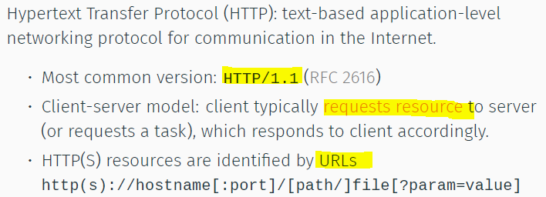

HTTP Request

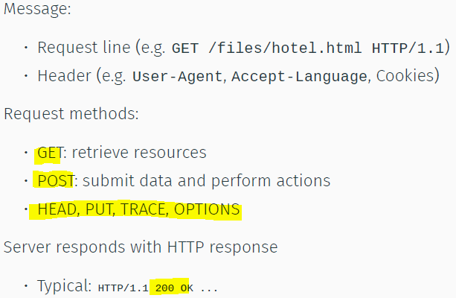

STATELESS Protocol

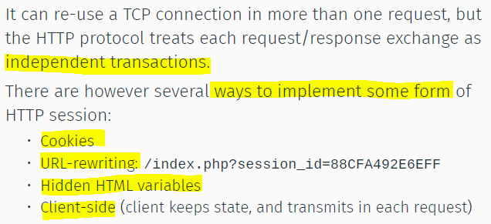

Cookies

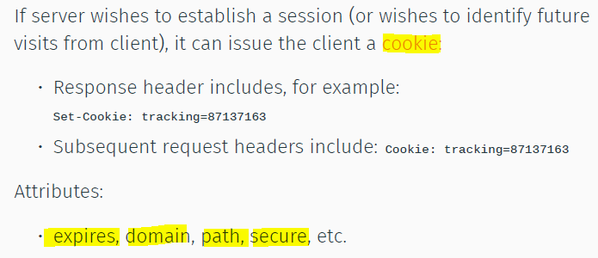

Encoding

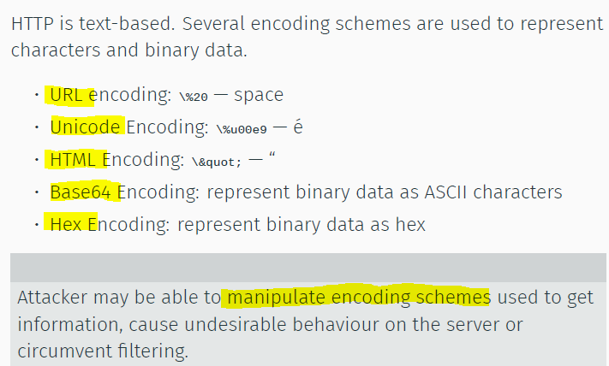

Web App Def Mech

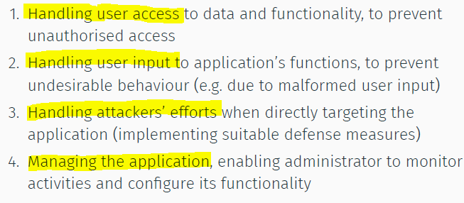

handling user access

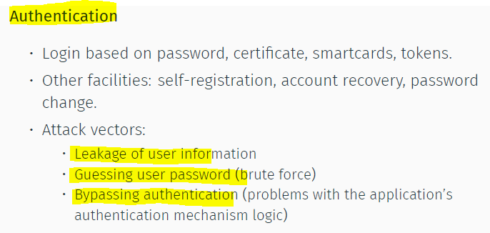

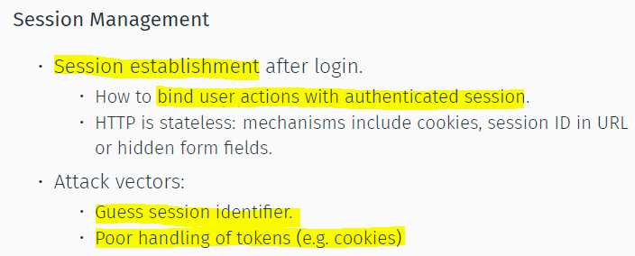

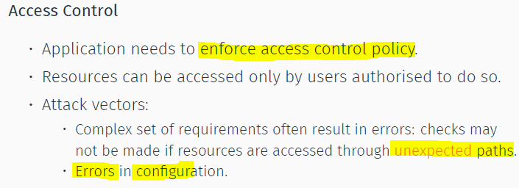

Handling user input

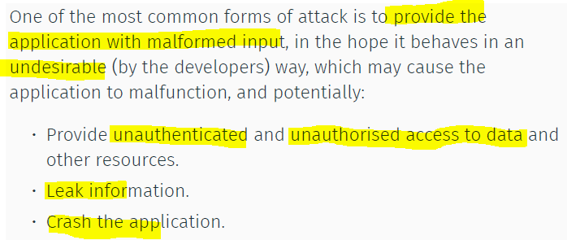

Types

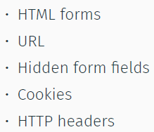

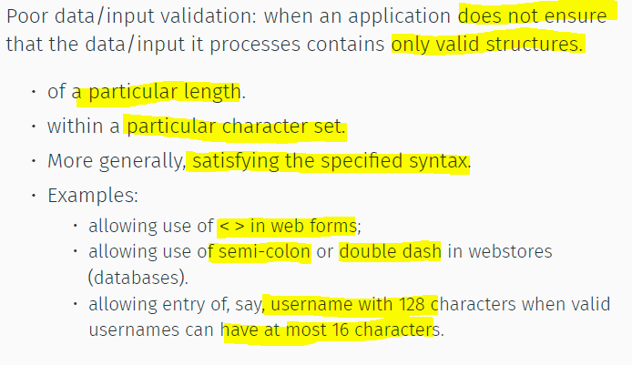

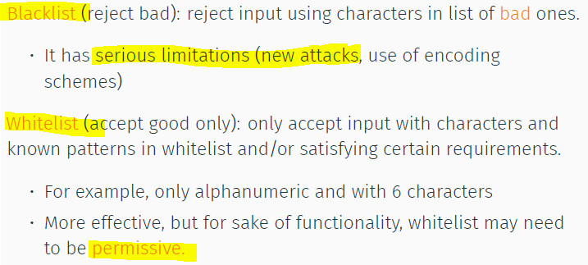

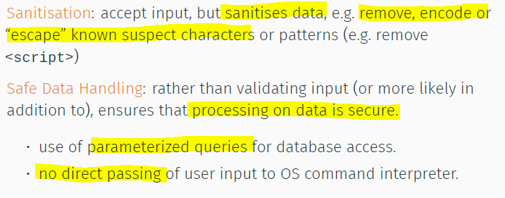

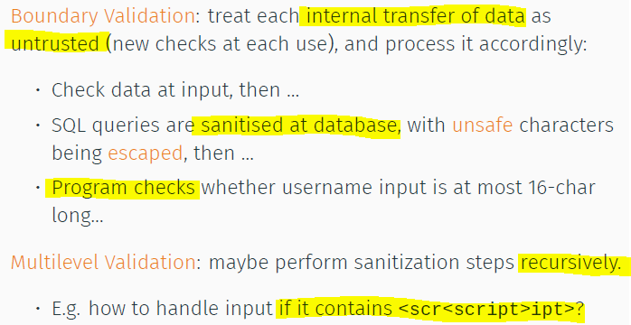

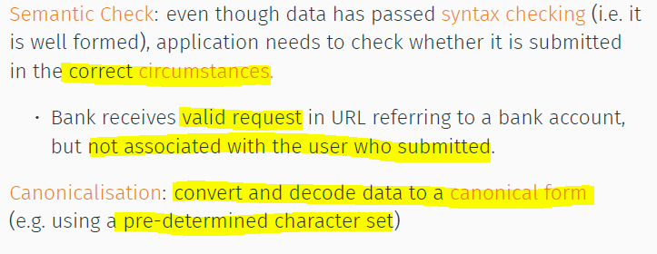

Handling Attackers

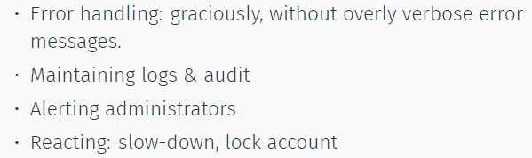

Managing the app  
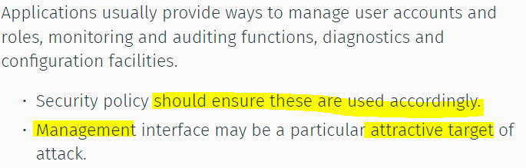

Gather info:

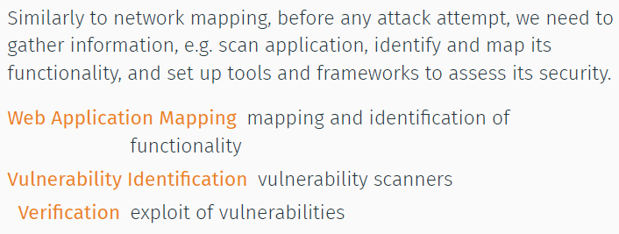

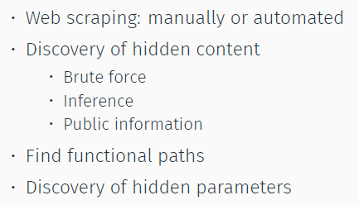

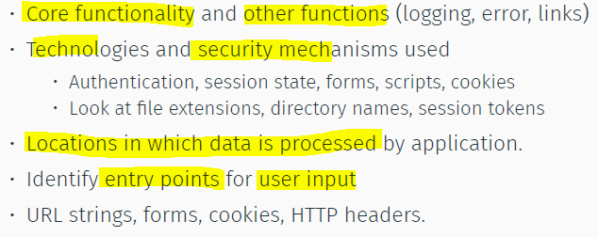

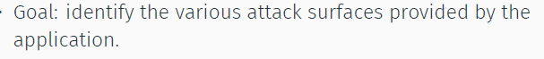

Targets

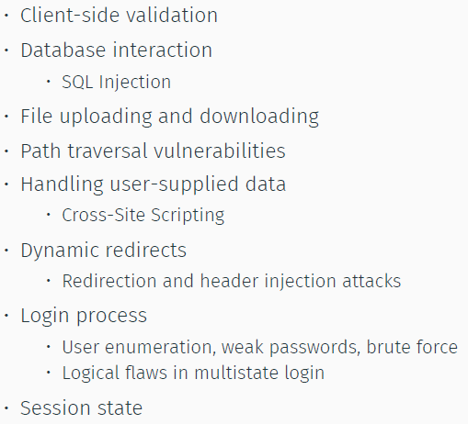

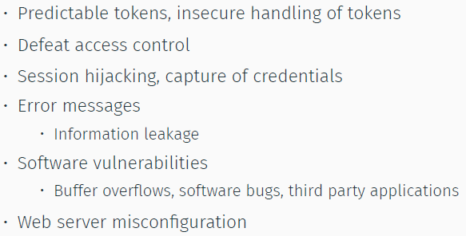

Scanners

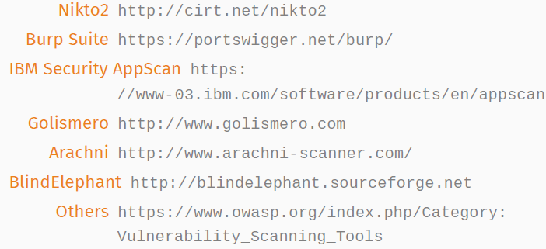

HTTP Proxy

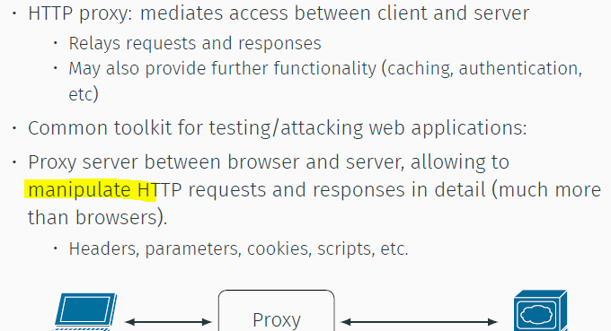

OWASP TOP 10

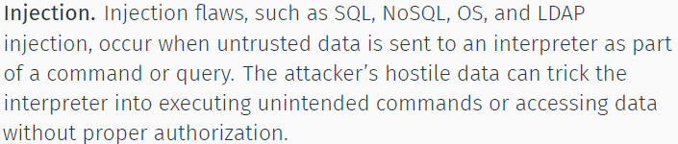

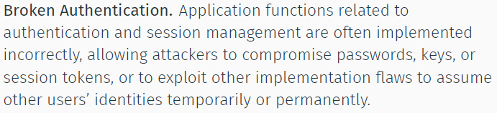

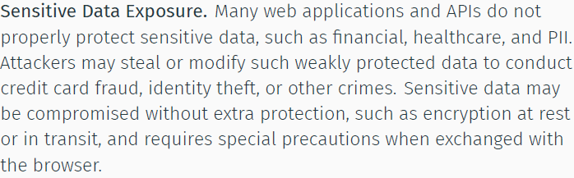

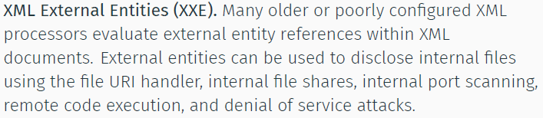

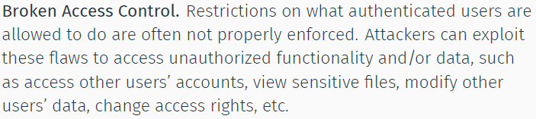

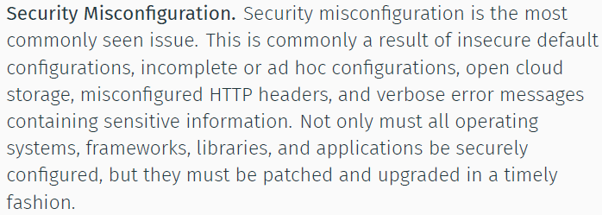

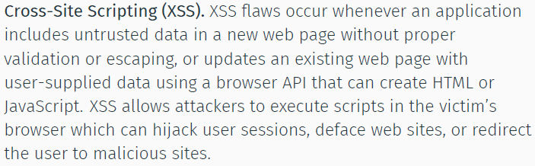

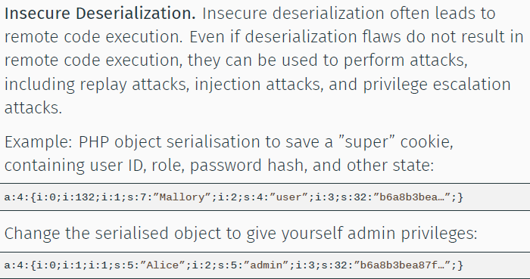

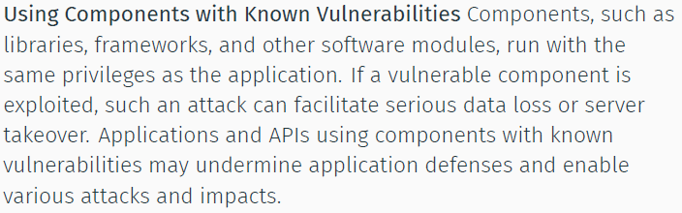

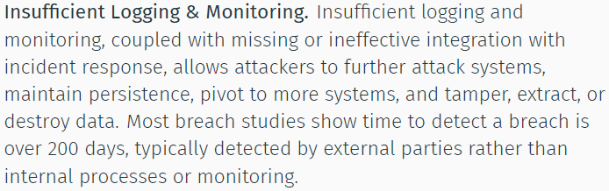

XSRF

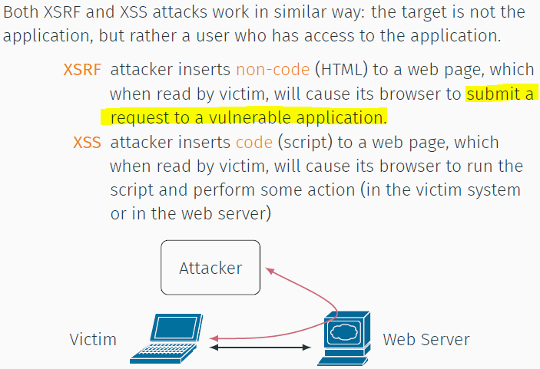

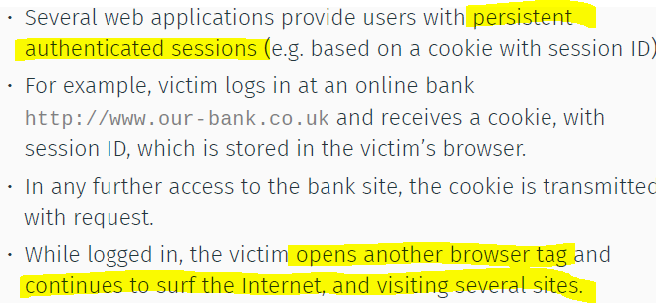

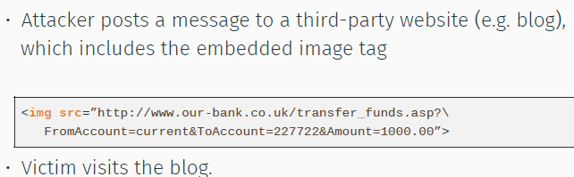

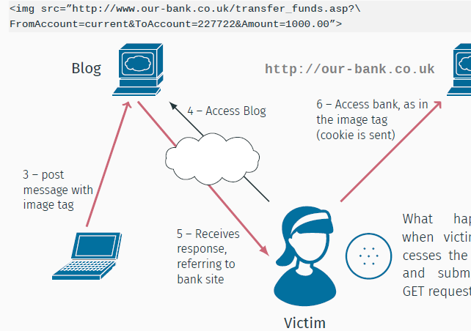

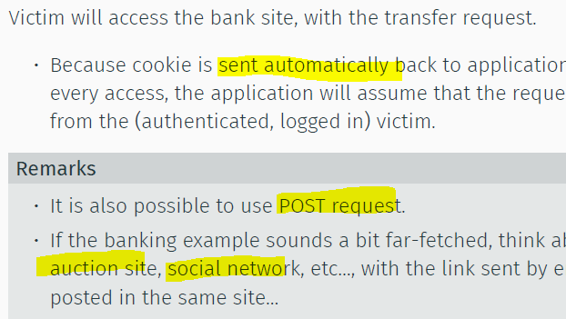

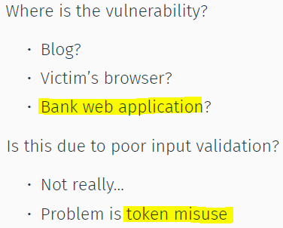

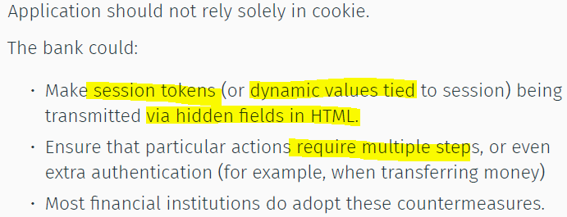

XSS

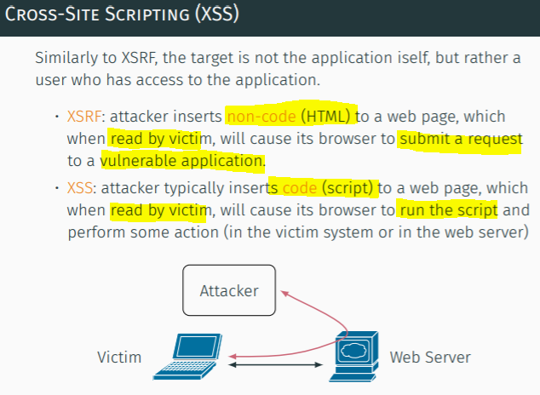

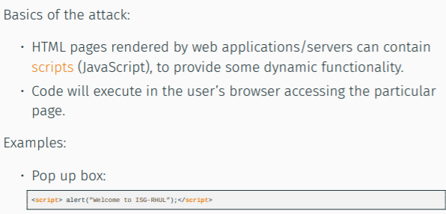

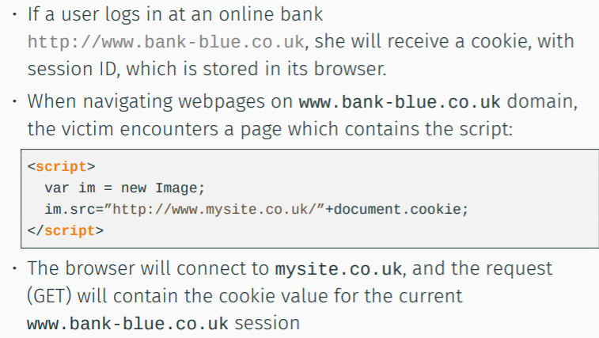

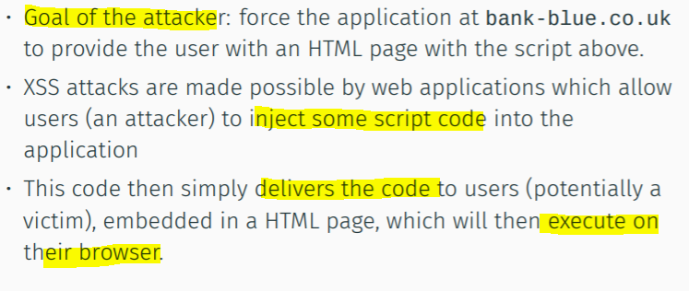

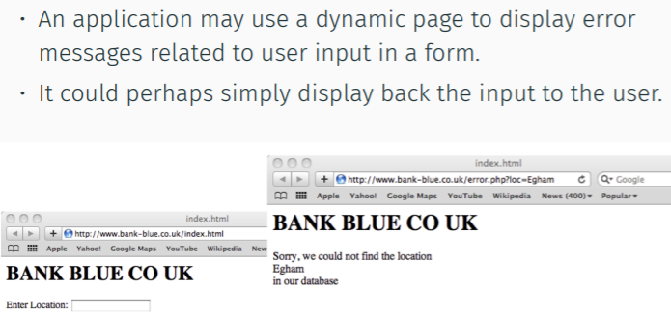

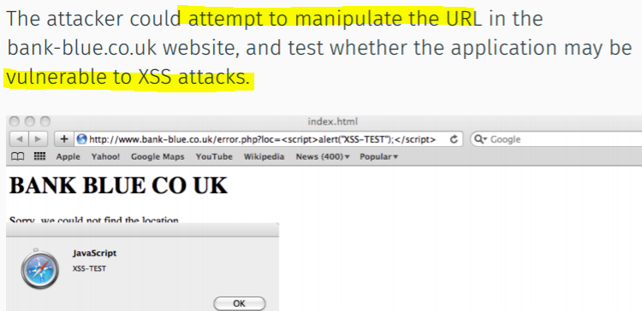

Reflected XSS

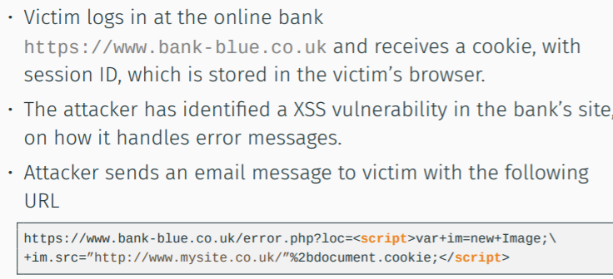

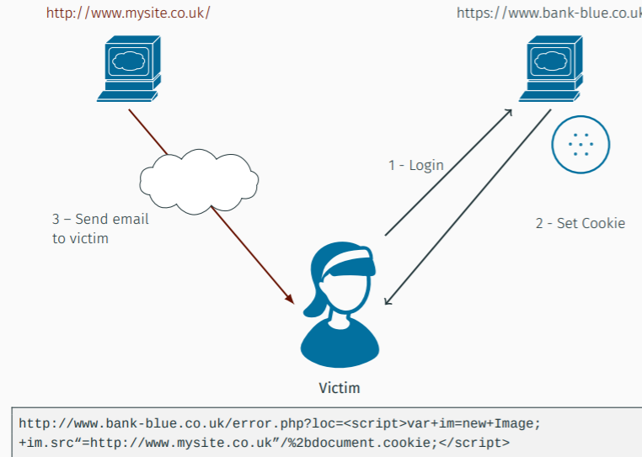

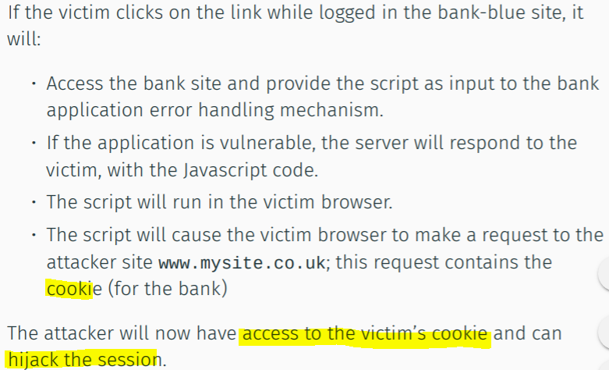

Why?

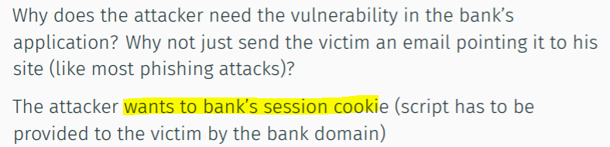

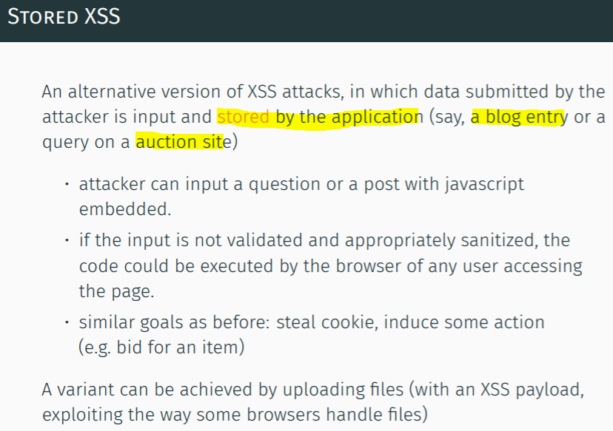

Dom-based XSS

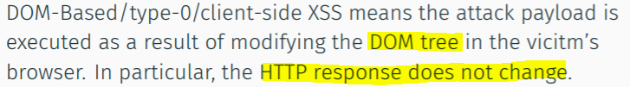

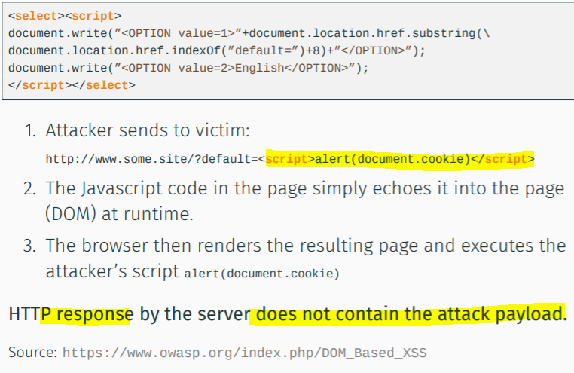

Defense on WebApp might not work, communication does not contain attack payload

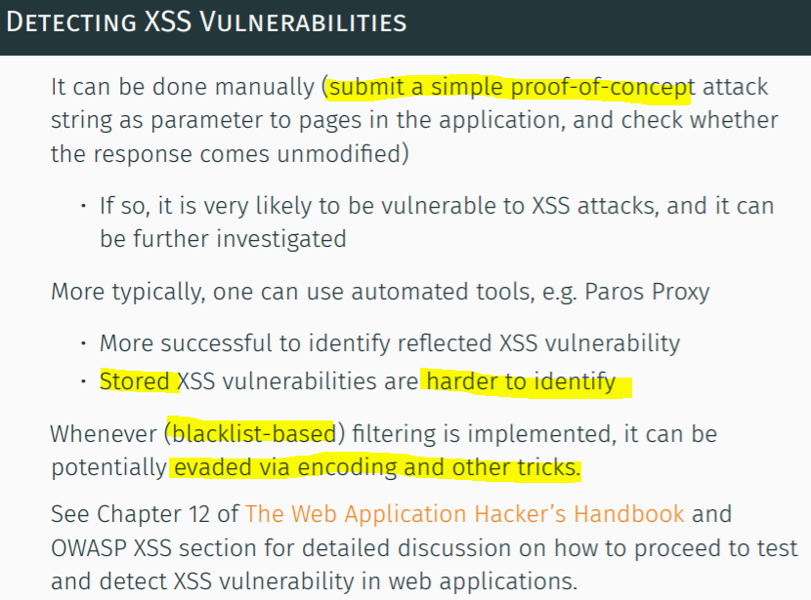

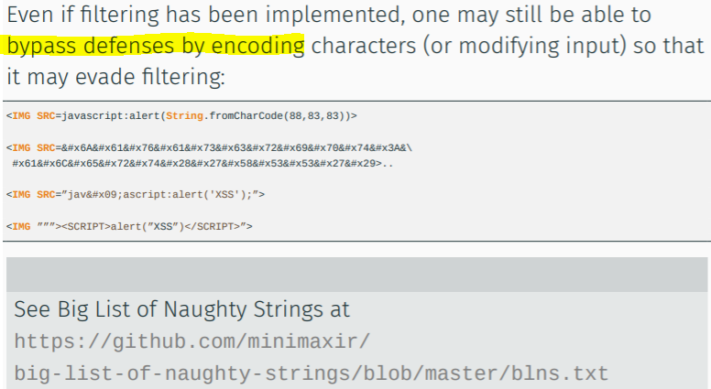

XSS Prevention

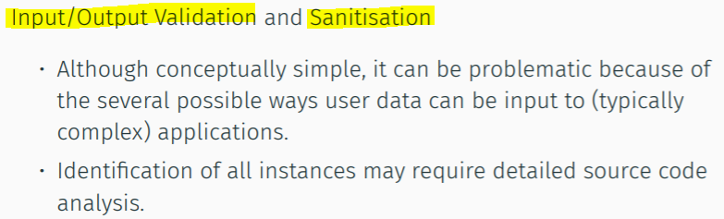

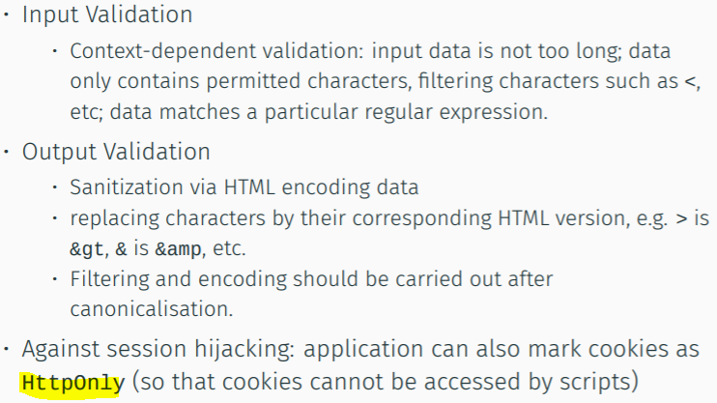

**Code Injection**

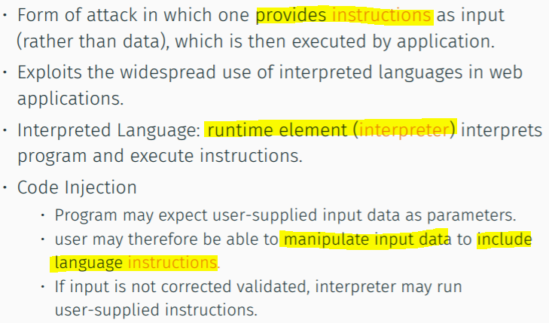

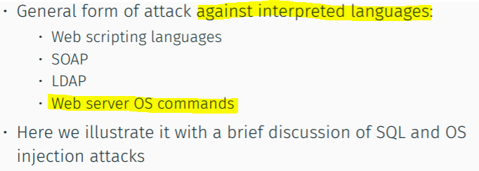

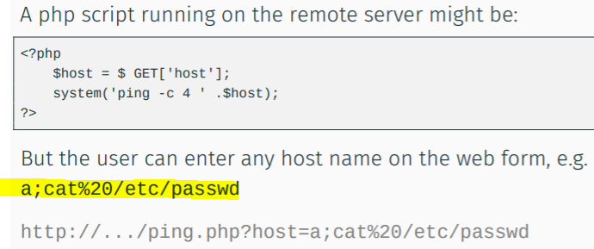

**Shellshock**

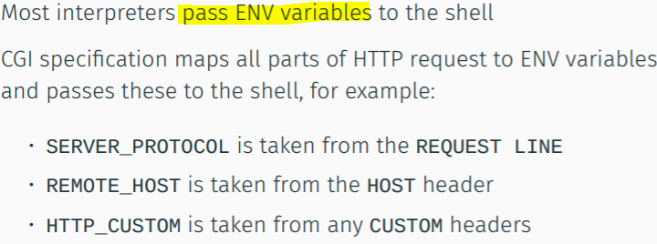

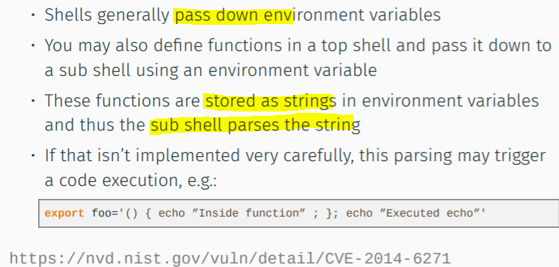

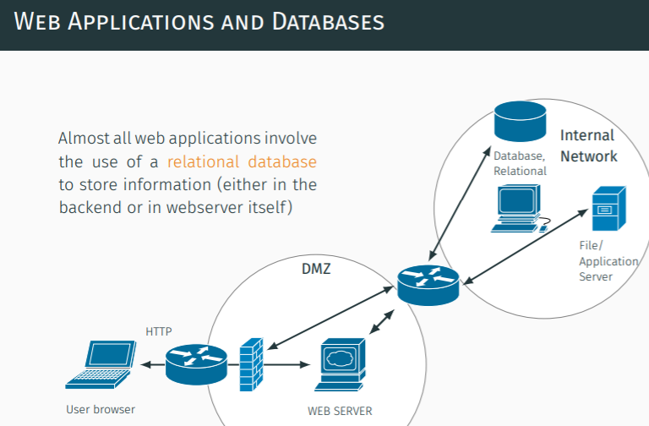

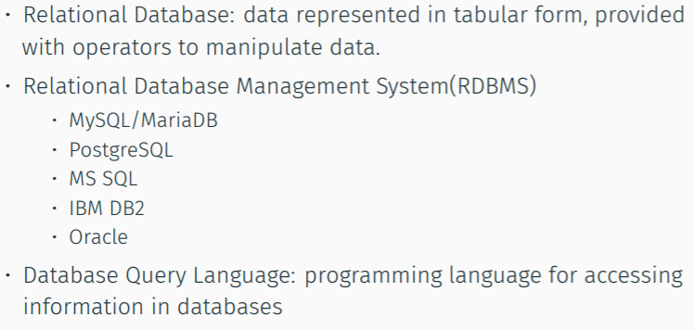

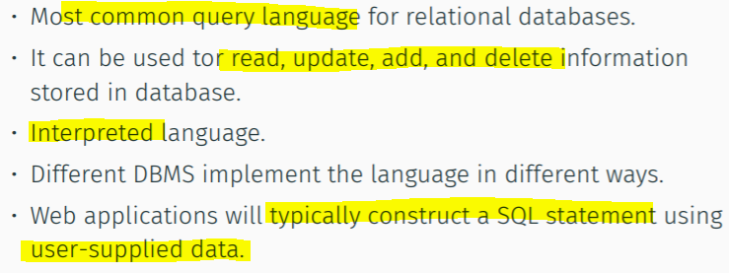

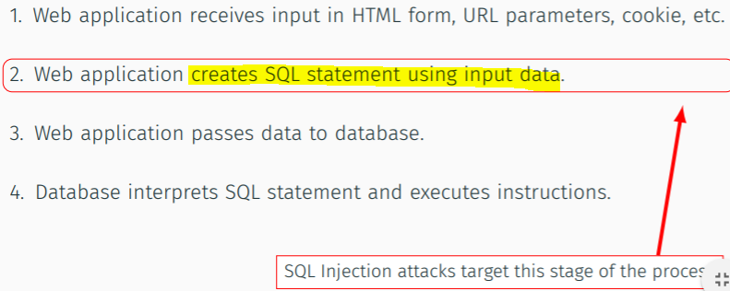

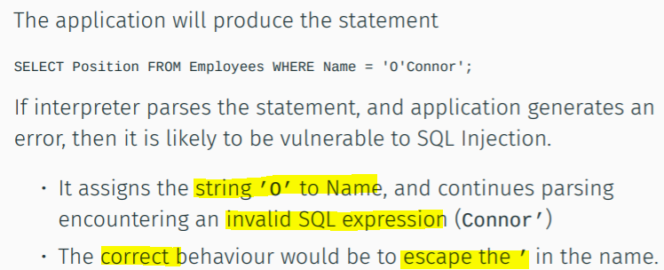

**Attacks**

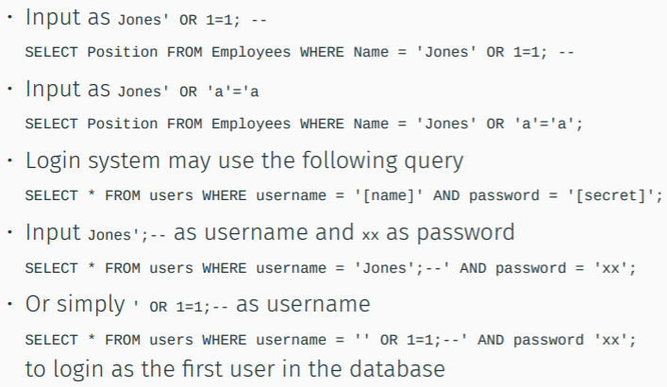

**Detection**

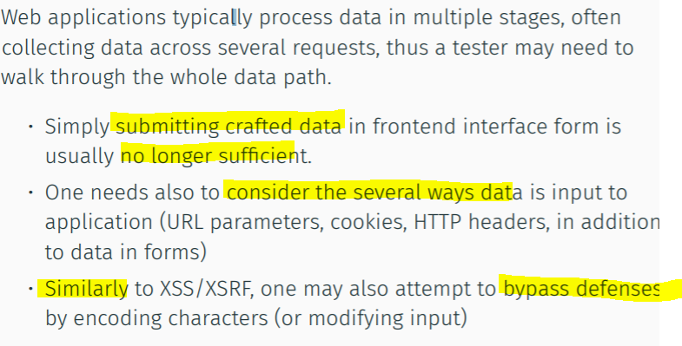

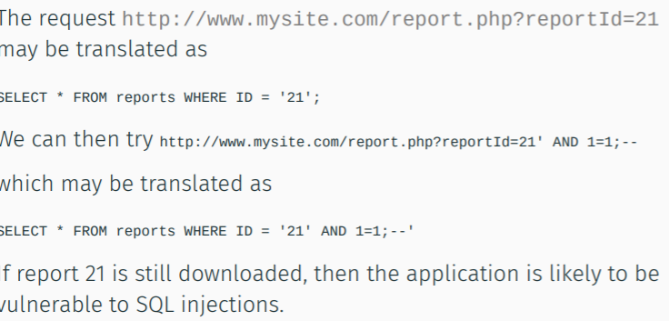

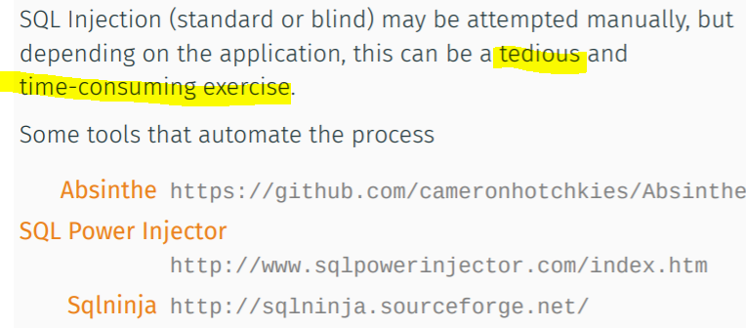

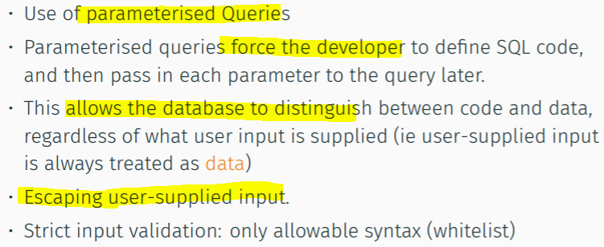

**Padding Oracle Attack**

**PKCS#1 v1.5**

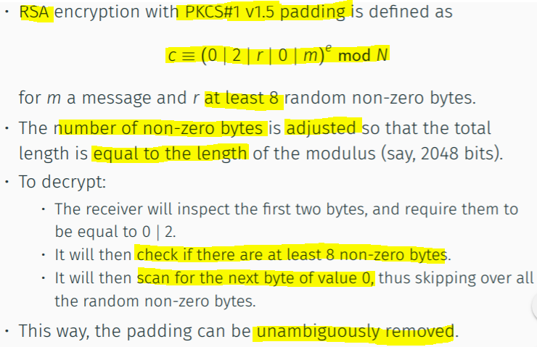

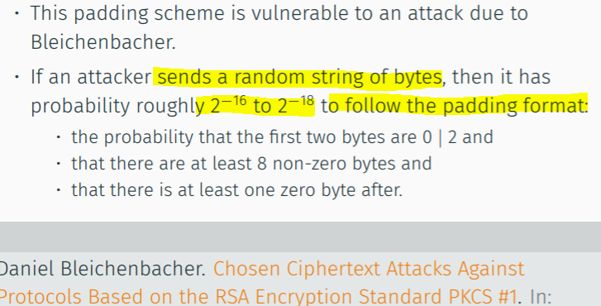

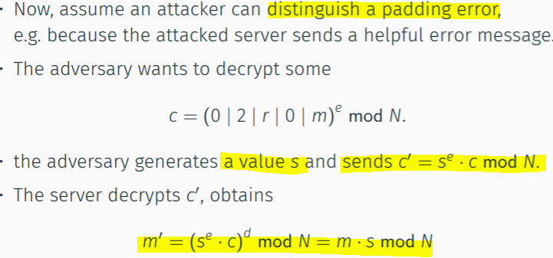

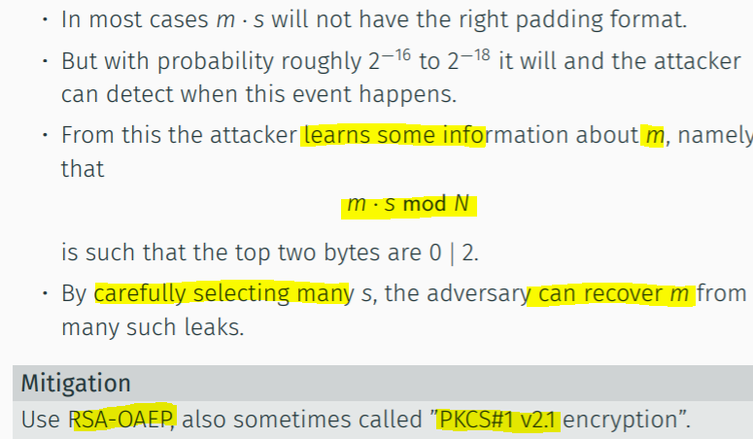

**Length Extension Attack H(secret|m)**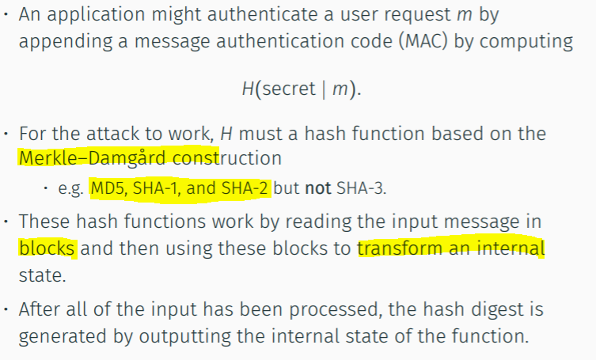

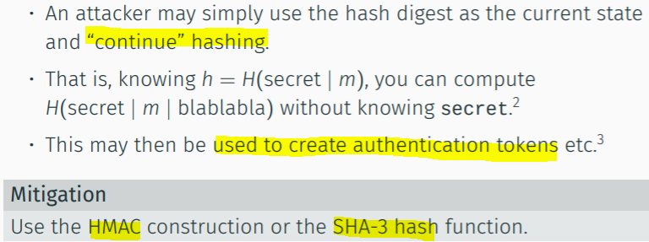

**2018 exam = closest style**

**Physical Security**

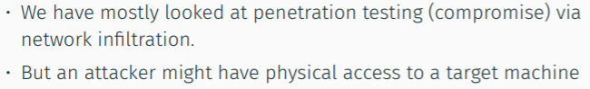

**Reboot**

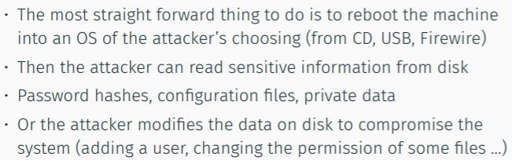

**Coldboot Attack**

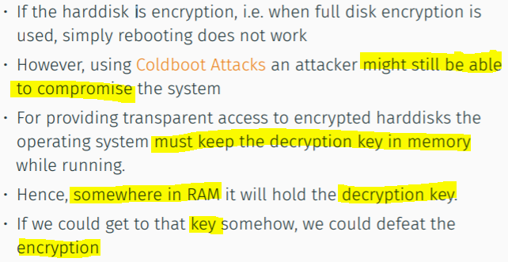

**RAM decay**

Freeze it to get the keys

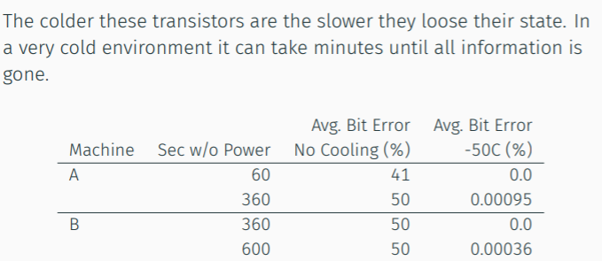

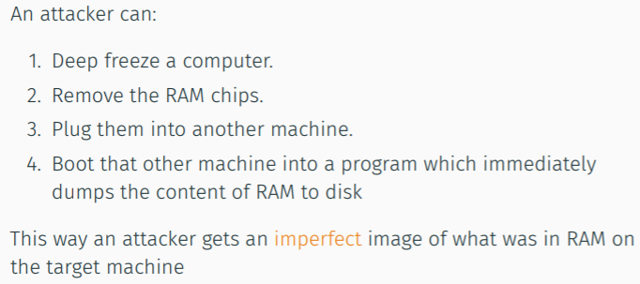

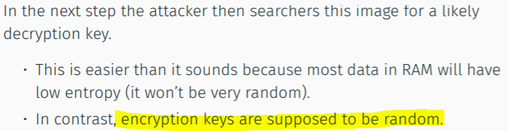

Recovery from the keys found  
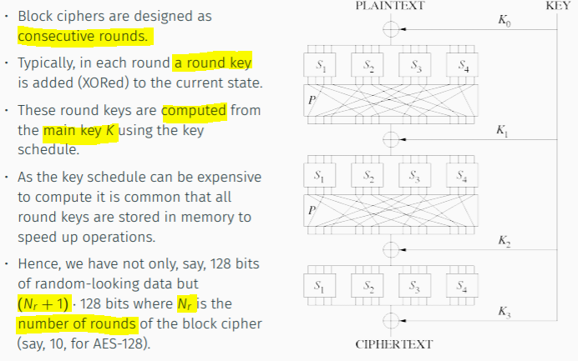

Recovery in algo

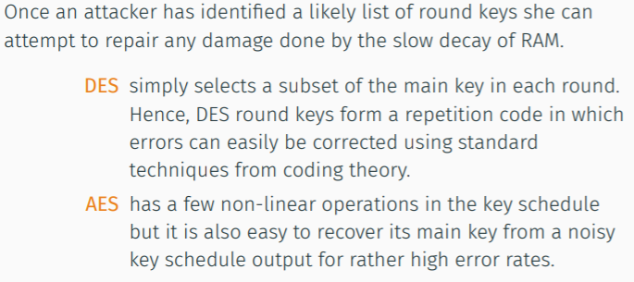

Coldboot Success Rate

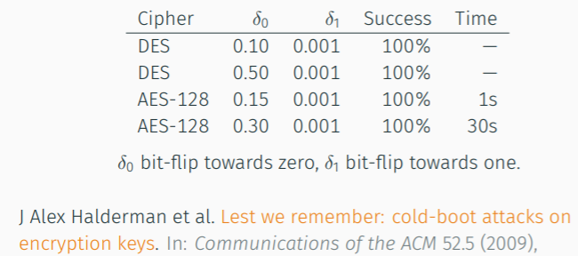

**Using I/O ports**

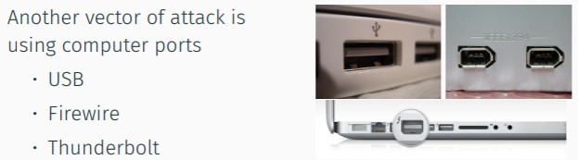

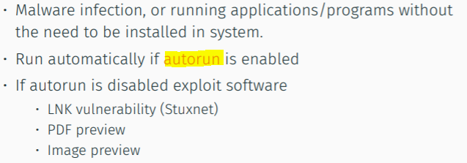

Against drivers as well

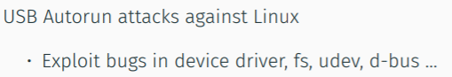

Firewire (high speed)

Thunderbolt (serial interface by Intel)

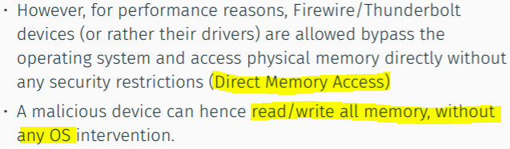

Privilege Escalation

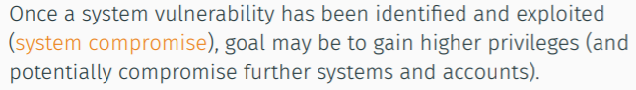

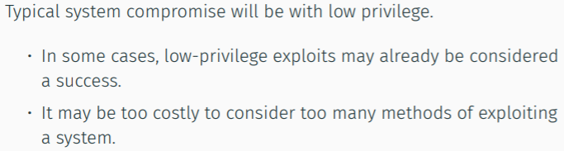

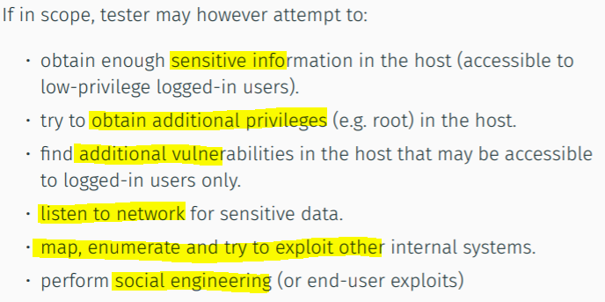

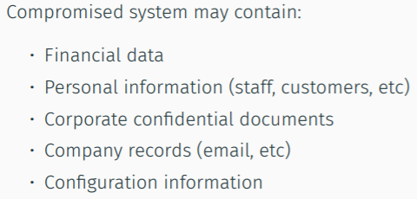

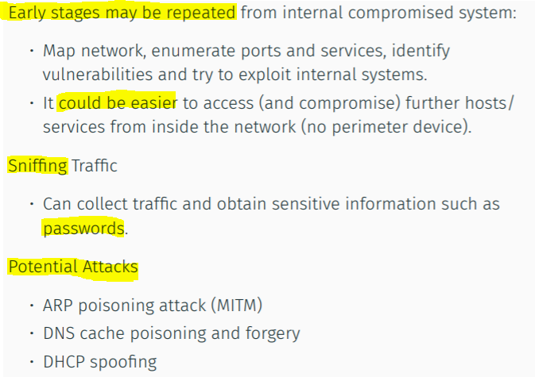

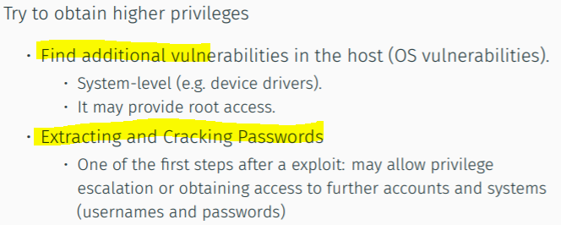

Password Recovery  
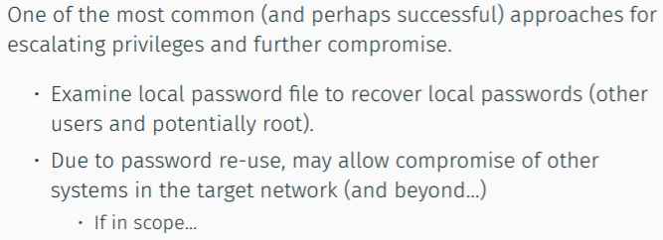

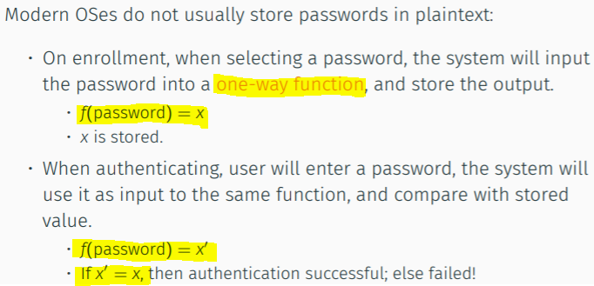

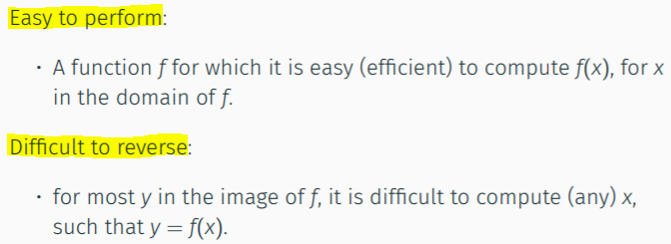

Candidates:

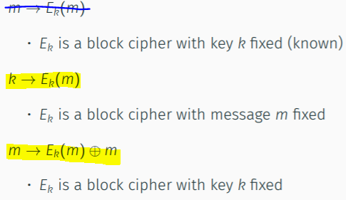

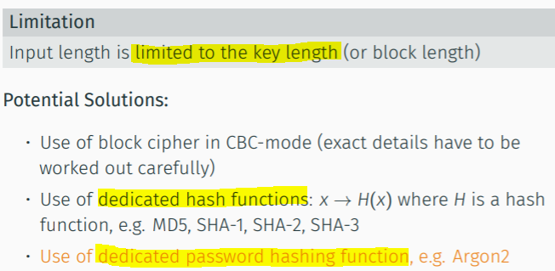

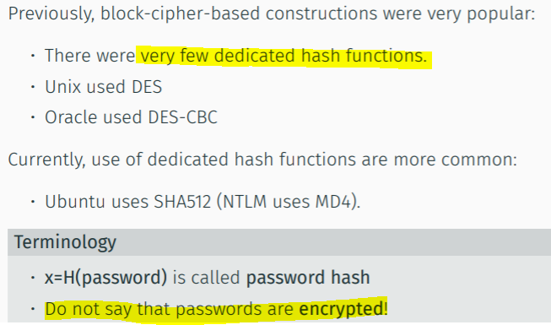

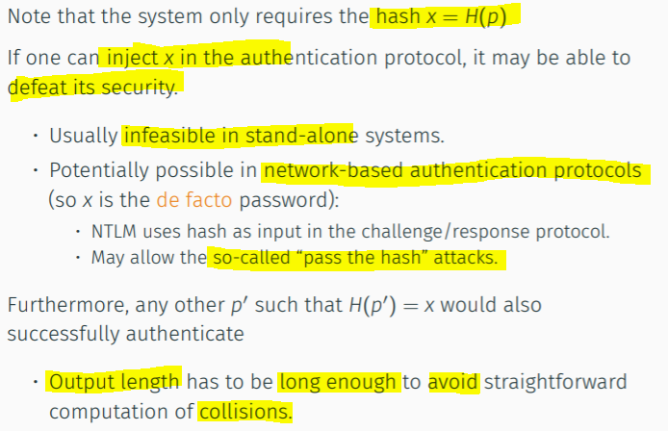

Password attacks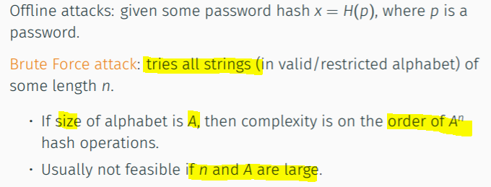

Password lengths

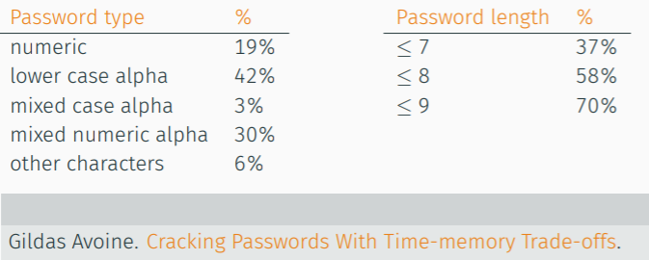

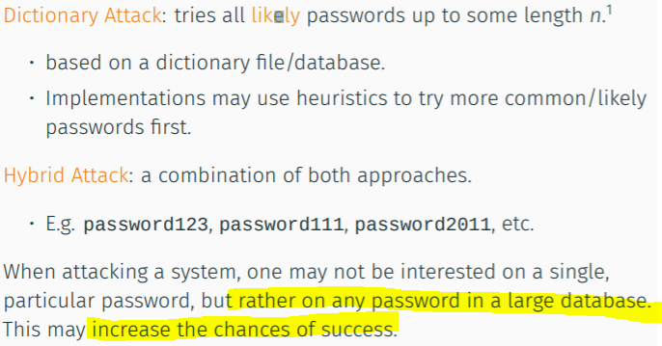

2 real-time approaches against pre-computation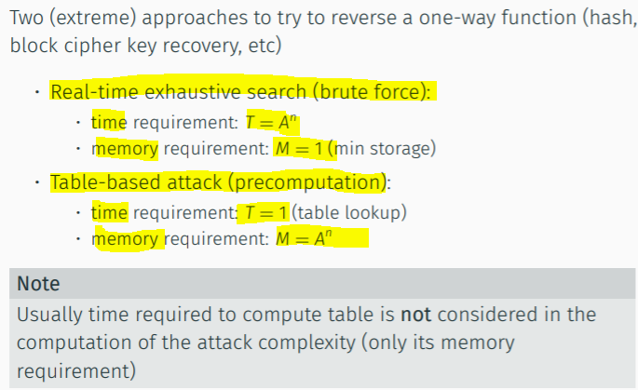

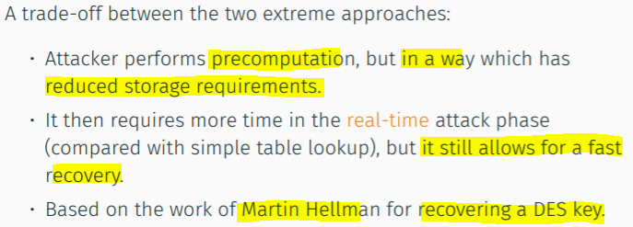

Martin Hellman = breaking key

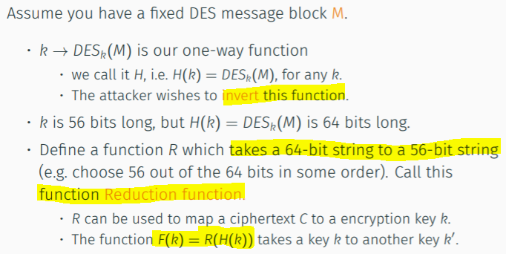

Generate table

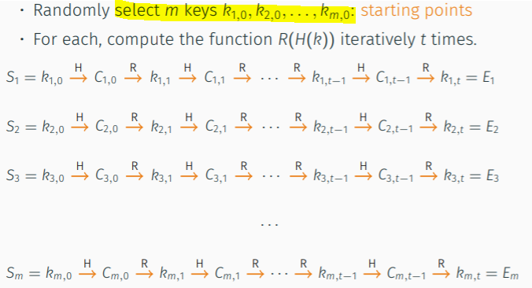

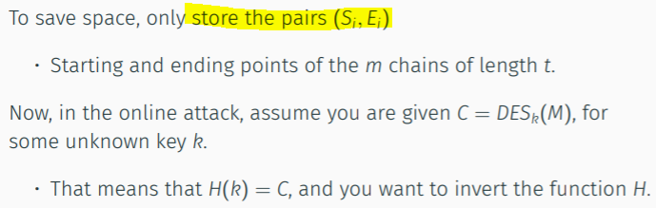

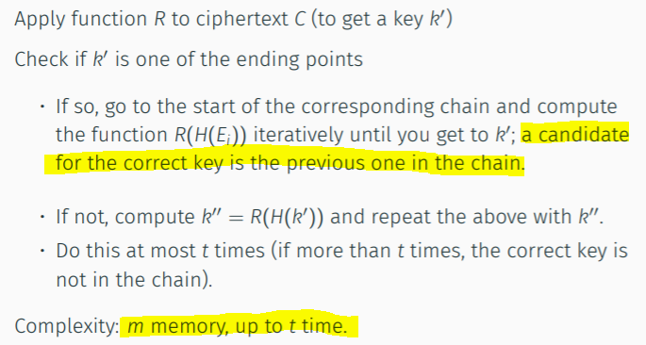

Best trade off = ( t = m = K^1/3)

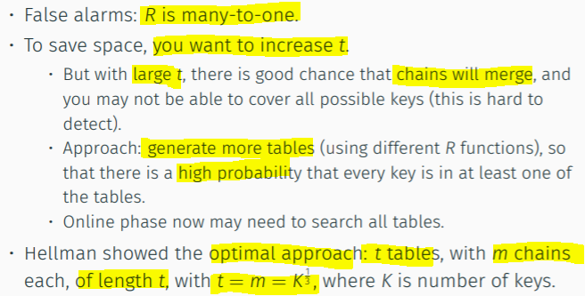

The entropy size is usually much lesser to crack

H = password hashing function

R = own Reduce function by attacker

Have many R functions (to prevent false alarm)

Rainbow Table

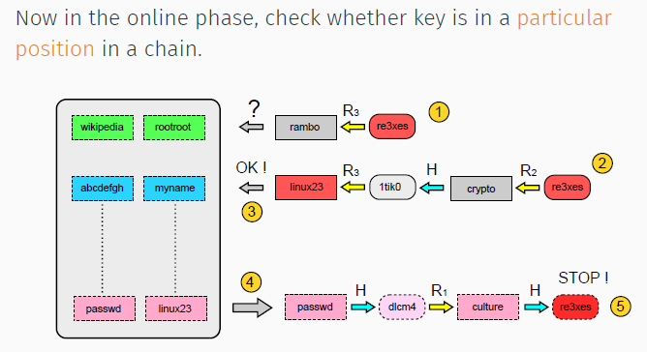

* Increase work online when checking a table
* Eliminates the danger of merger of chains, reduce no. of tables
* More efficient

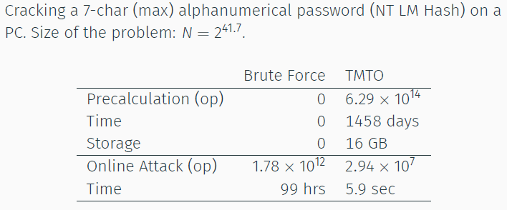

Best Practices

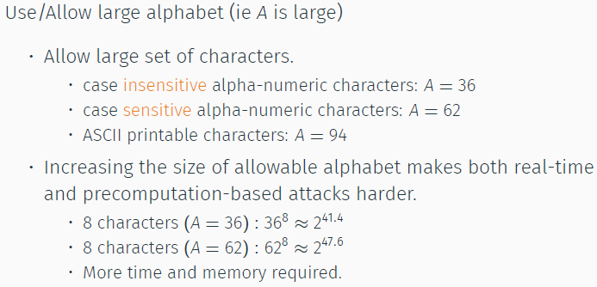

Make Function H() show

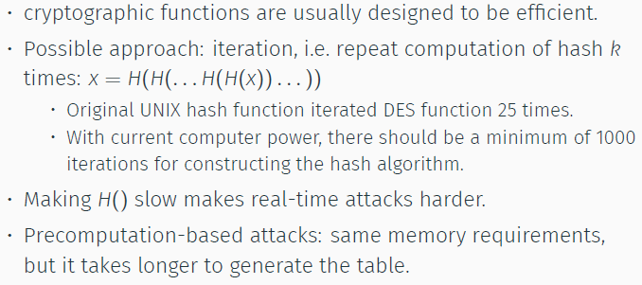

Use of pw salts

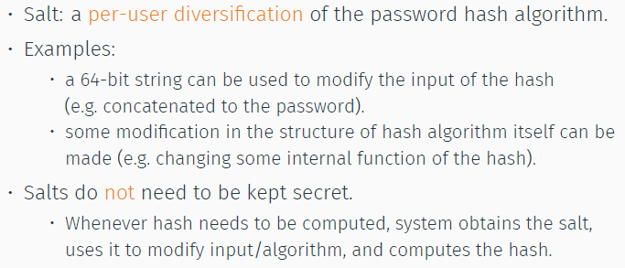

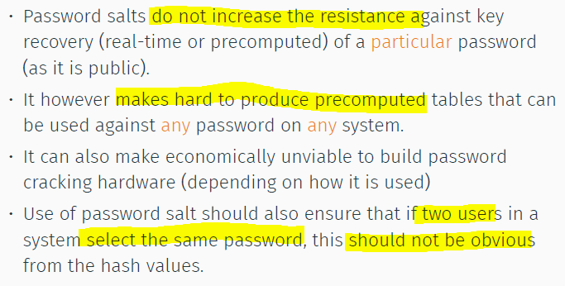

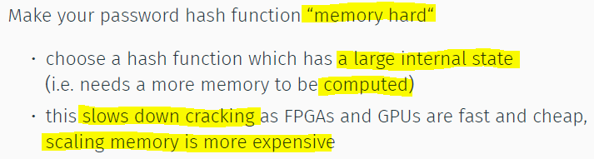

Linux pw hash= SHA512, no limit in length, 5000 iteration, 48bit salt

Windows Lan Manager

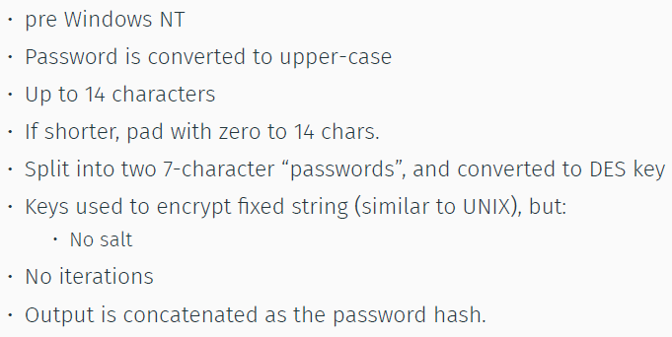

NT hash

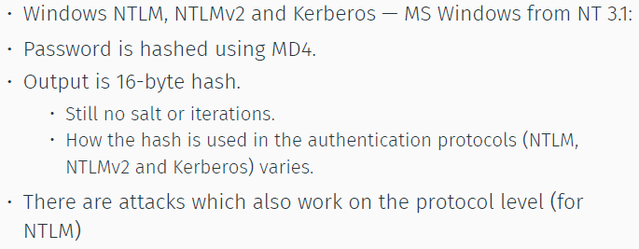

Argon2

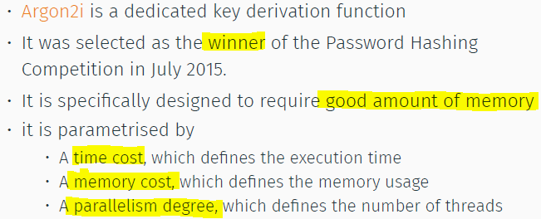

FB pw hash

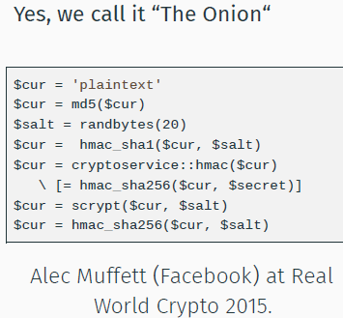

PW hashs

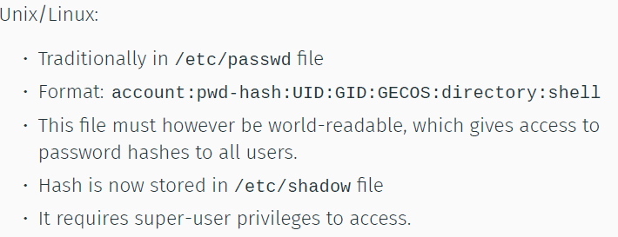

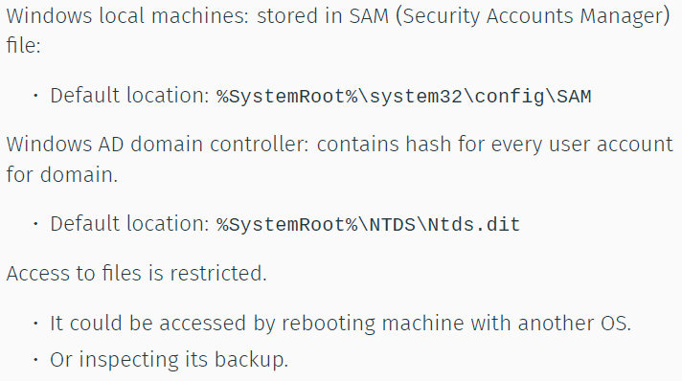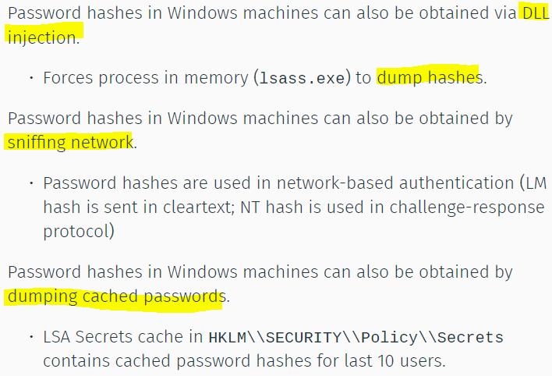

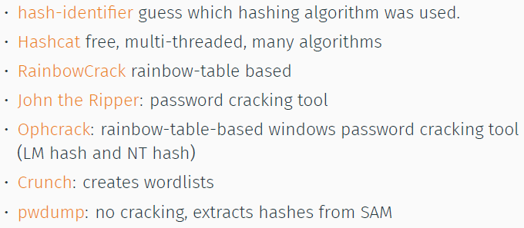

**Maintaining Access**

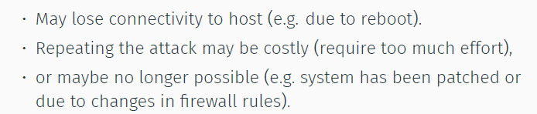

Possible = backdoors/rootkits/covert channels

**Covering Tracks**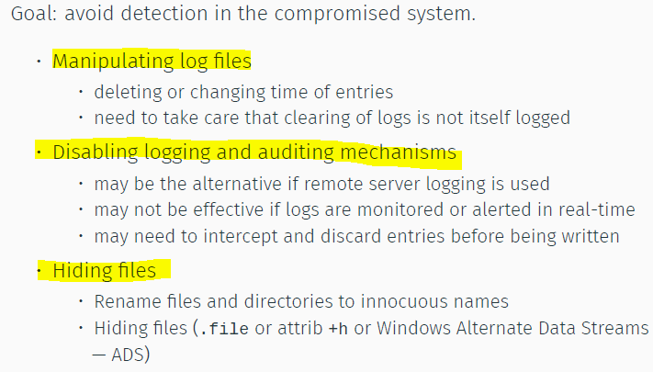

**Backdoor**

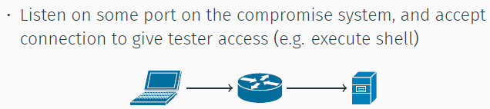

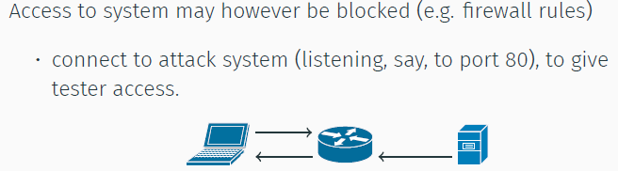

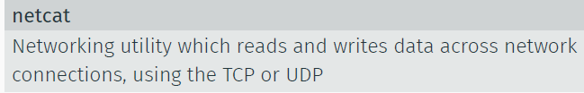

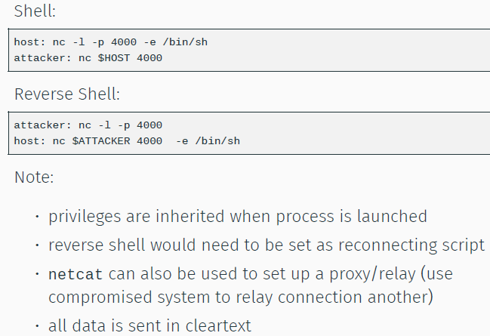

Encrypted tunnels = SSH, socat, stunnel

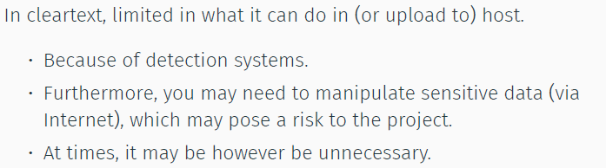

**Professional BD =** usage of weird pw string.  
- Bad EC constants, to predict output.   
- juniper replaced NS constants, but bug prevented.   
- Someone breaks in, replaced juniper constants with ow. 3rd in a row to BD screenOS

**Rootkits**

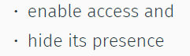

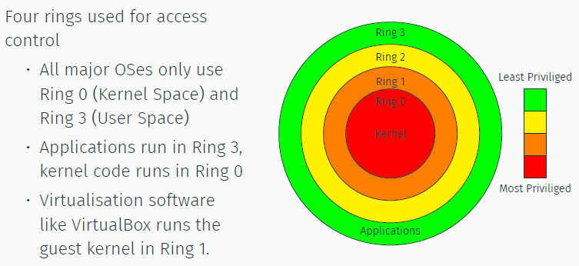

**Where to put it?**

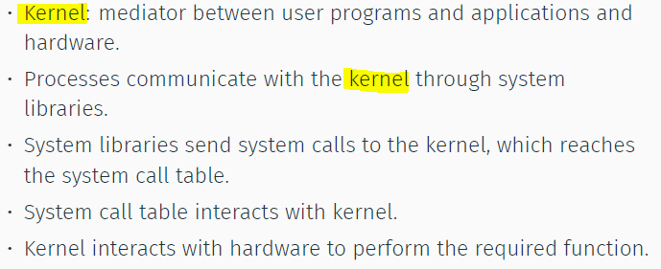

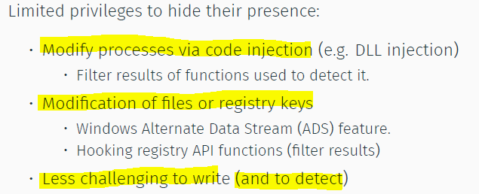

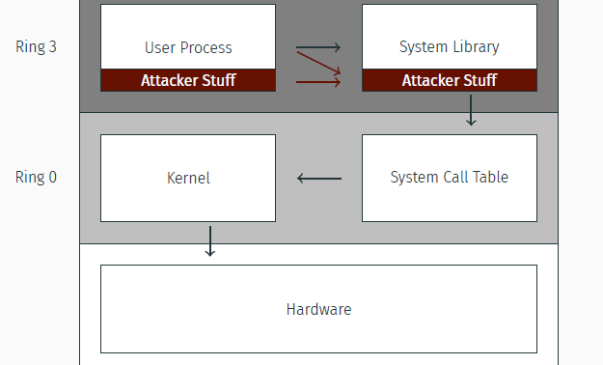

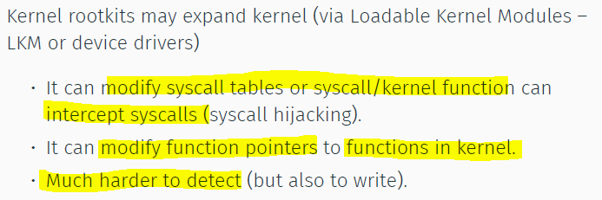

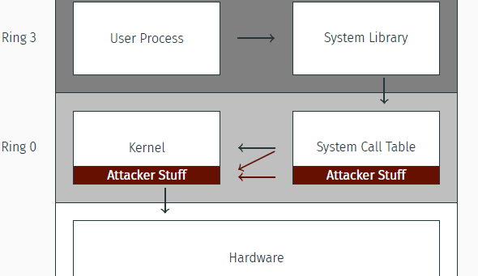

**HW rootkits**

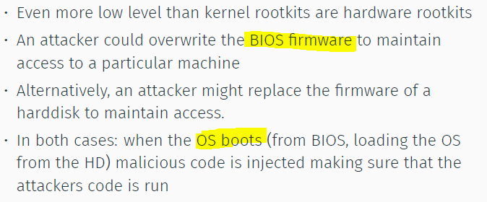

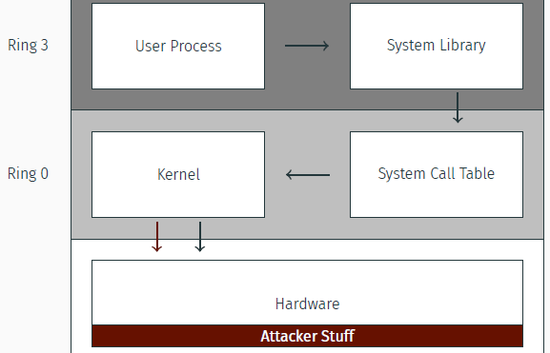

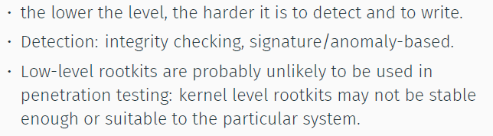

**Covert Channels**

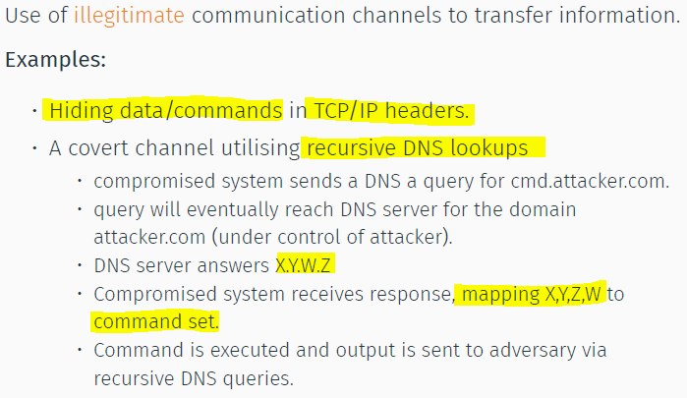

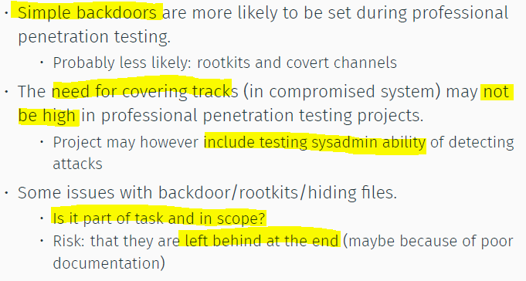

**Documentation & Reporting**

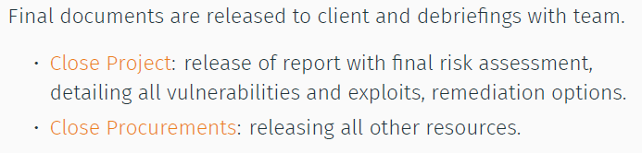

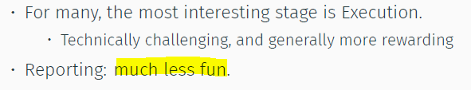

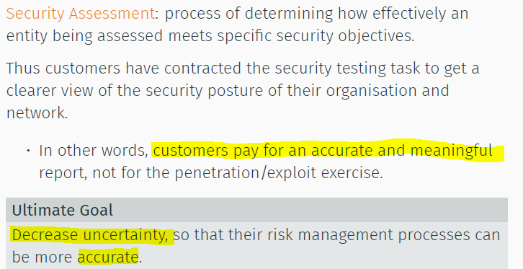

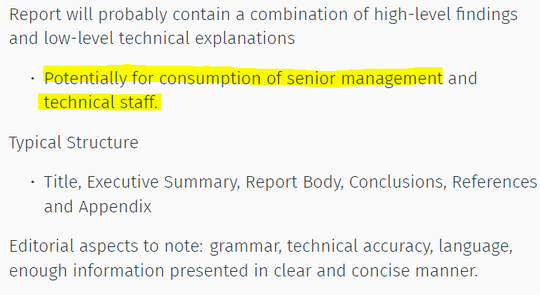

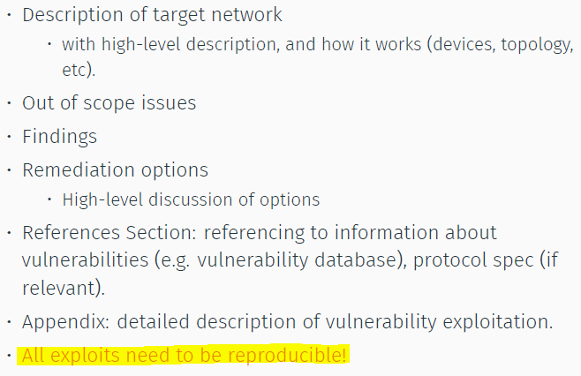

**Out of scope items:**

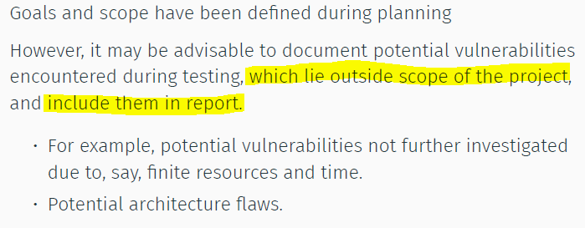

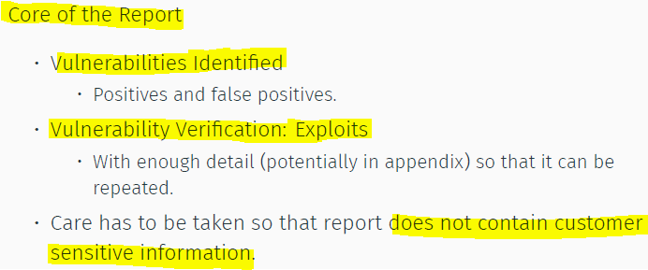

**Remediation options**

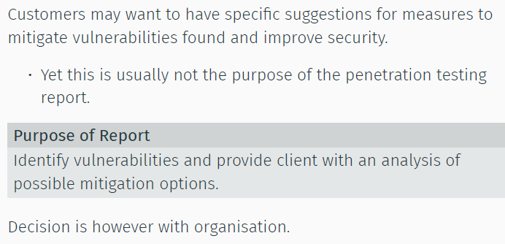

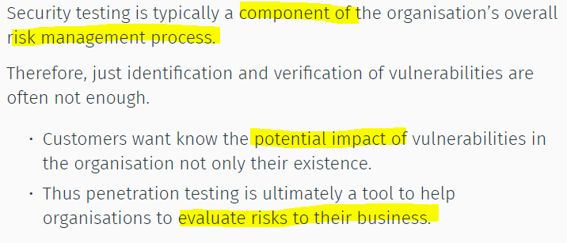

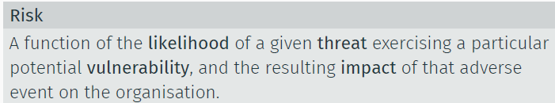

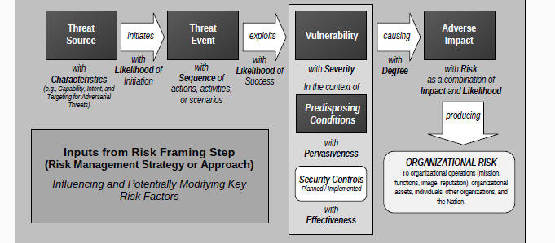

**Likelihood determination**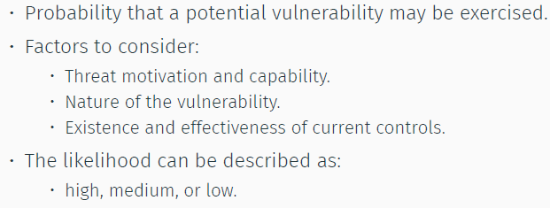

**Impact analysis**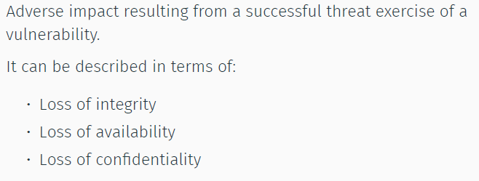

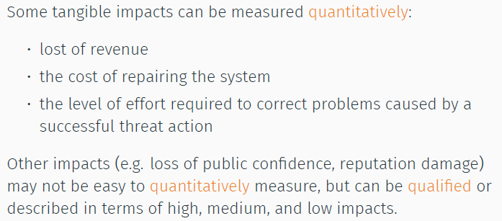

**Risk mitigation**

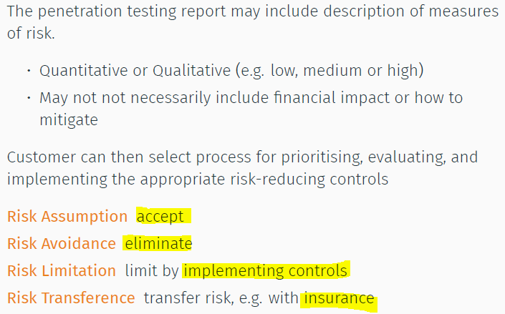

**Data handling**

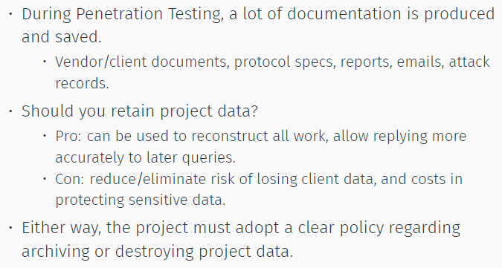

**Document handling**

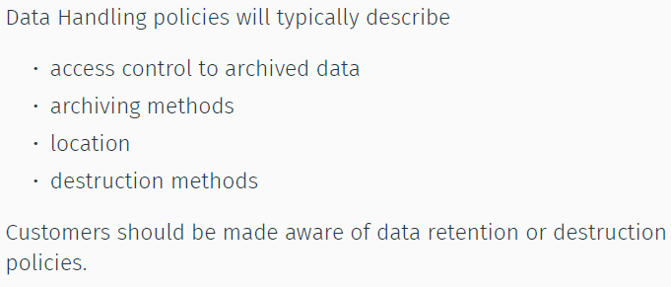

**Secure Project data**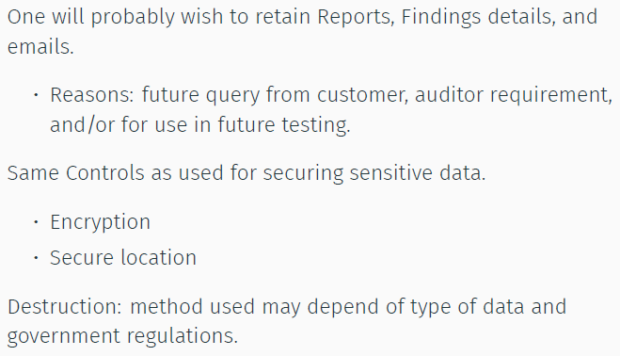

**Legal & ethical questions in pentest**

Why care?

R = f(P, D, Q, X)

R = Risk weight cost that a given rule will be enforced successfully against you by a given person

P = the “prima-facie case” to prove violation of rule

D = affirmative defences that reduce or negate liability for having failed to follow “the rule”

Q = quantum of liability if the rule is successfully enforced

X = other factors….

**Computer misuse**

* Nature of liability
  + Antihacking laws
  + Generally, this is criminal liability for
    - Accessing a com, attempting…
    - Without authorization
* UK Computer misuse act 1990 Sec 1
  + Sente: max 12 mths in custody/fine
  + Jurisdictional scope: (in any of)
    - Target computers in UK
    - Machine used to launch/enable hack is in UK
    - Hacker is in UK

**Avoiding liability**

* Confirm activity is authorized by person holding authority
* Does the person who grants permission to tester **actually hold authority** to grant it ?
  + Worst-case: false flag
  + Less than worst: staff member gone beyond their own corporate brief?
  + Another bad case: does person hold authority to grant permission to access ALL target machines?
* Negotiate and delineate scope of pentest
  + Clear, agree, stick on it
  + Acting beyond authorization = **crime**

**Interception of comm**

Nature of liability = blinding array of law that penalize unauthorized interception of emails/voicemail

* Interception include activity such as reading emails in an in-box

Scope of UK law

* IPA 2016: interception on a public/private sys a crime & give “FR/TO” parties right to sue personally
* Private system operating: Granting permission…

<more info>

**Negligence**

= **breach of duty of care that proximately causes damages**

* Duty
* Breach
* Causation
* Damage (quantum of loss)

= “Breach of duty of care” = “negligence”

When does duty of care exists?

* Diff cultures (diff legal sys) around the world
* Answer = culture-specific

(By geog, time, shift assumptions about commerce, means of comm, property ownership, ability to influence on another’s lives)

**Duty of Care TEST**

*Caparo Industries plc V Dickmam (1990)

* **Foreseeability of harm** to victim
* **Relationship** of proximity btwn parties; &
* **Court** considers it **fair, just, and reasonable** to impose a duty of care

**Breach of duty ?**

**Reasonable** man Test

* Reasonable person similarly situated have done this?
* Measured by SUPPOSED actions of reasonable ppl

“Reasonable” changes all the time (geog,time,culture)

“Common practice is not the same as reasonable practice!” = 95% of the ppl can be wrong

Follow up:

Learned Hand Formula

“If B< PL, then negligence”

B = cost to implement technological fix

P = Probability of loss without the tech

L = probable amount of loss

Need to lookout for beneficial tech, whose cost is going down. Don’t miss adopting tech (reasonably priced) (**B is decreasing**)

Need to look out for changes in external env (**P is increasing**)

**Tort Defences**

**Affirmative defences include:**

* Assumption of risk
* Consent
* Necessity
* Contributory negligence; or comparative fault

**Role for contracts and notices**

**Negligence Risk Reduction**

**Liability to whom?**

* **Client**
  + Careful scope can prepare consent def
  + Explanation of risks can prepare assumption of risk def
* **3rd parties**
  + Consider how your actions might impact persons other than your client (business customers, staff members, unrelated party)

**Contract**

* **Liability limitation/cap** (highly regulated clause!)
* Indemnity from client if 3rd party liability incurred

**Description of services**

* Do u have the “EXPERTISE” that you claim?
* Law of negligence often requires u to act at the lvl of expertise tt u PRETEND to have (if this is better than ur actual level of ach)

**Data protection/ Privacy**

* **GDPR**
  + Becomes 1st tier regulatory, as potential downside increase a lot.
* **Commission Decisions**
  + Transborder data flow adequacy decisions

**Players**

* **Data Subject:** living person to whom that personal data relates
* **Data Controller:** person who controls the dissemination of the personal data
* **Data Processor:** person who merely processes personal data at the instruction of data controller

**Processing personal data**

**Personal data** = **capable of being attributed** to a living individual by any person even if that person is somebody other than you e.g. IP addr

Personal Data > PII ( in terms of coverage)

**Discovered things**

**Evidence of :**

* Embezzlement
* Staff hacking (or hack back)
* Child porn
* Money laundering
* Copyright infringement

**Typical Conundrum**

* Am I mandated by law to report to police?
* Am I allowed by terms of engagement to report to police?
* Am I prohibited from reporting to anyone but client?
* Am I prohibited from reporting to client?

**Managing liability**

* Don’t ask a question if you are not able to deal with answer
* Investigate the “mandatory reporting” laws applicable in jurisdiction
* Make clear in service agreement if some types of evidence must be reported directly to authorities
* Special caution if you are retained by law firm as part of their engagement by 3rd party client: your investigation may constitute lawyer-client privileged work product and you maybe prohibited from disclosing evidence obtained.

**General Observation**

**Regulatory movement**

* Pentest slowly moving into regulated space. Harm can be caused by practitioners is so great, growing pressures for a system of societal standards and oversight
* UK, CREST taken a pre-eminent position in trying to self-regulate domain

**Always rmb WHO is YOUR CLIENT?**

* Practitioners often become confused
* To whom, exactly, do you owe a professional duty?
* What does it take to fulfil that duty?